JAMSHEDPUR WOMENS COLLEGE



PROJECT REPORT

DEPARTMENT – “BACHELOR IN COMPUTER APPLICATION"

BATCH: - 2018-2021

Semester- 6th Sem

TOPIC-

“STUDENT RECORD MANAGEMENT SYSTEM”

Team Members: -

Saloni Jha (18VBCA23095)

Shalini Dubey (18VBCA23096)

Shruti Jha (18VBCA23099)

**ACKNOWLEDGMENT**

I would like to express my special thanks of gratitude to my teacher **Mrs. Sangeeta** as well as principal **Dr. Shukla Mohanty** who gave me the golden opportunity to do this wonderful project on the topic (**Student Record Management System**), which also helped me in doing lots of Research and I came to know about so many new things.

In addition, I would also like to thank my parents, friends and Team members who helped me a lot in finalizing this report within the limited time frame. I am extremely grateful to my department staff members and friends who helped me in successful completion of this project.

**INTRODUCTION**

* **We have designed this website with the purpose of allowing the school to make their work precises and handle the data accurately.**
* **This website is an attempt to remove the existing flaws in the manual system of taking attendance of students and sending the notice.**
* **Teachers are provided with the flexibility to mark the attendance of student on daily bases and send the notice to the students at any time.**
* **Students will be able to see their attendance report whether they have been marked present or absent on the particular day.**
* **Student can see their profile.**
* **Student can see their Annual Attendance report and the Notice send by the teacher and the school office.**
* **Admin is the school office authority who register the student with their details in S3 School Website and send the office notice to the students.**

**PROBLEM STATEMENT**

The problem occurred before having web Application includes:

* File Lost: - When web Application is not implemented file is always lost because of human environment, due to some human error there may be a loss of records.
* Difficult to search and Manage Records: When there is no web Application there is always a difficulty in searching of records if the records are large in numbers. It is very difficult to manage the records manually.
* Space Consuming: - After the number of records becomes large the space for physical storage of file and records are hard to manage.
* Transparency: - In the Manual system the students were having difficulty in seeing their records whenever they want.
* Hard to Access: - When the web Application was not implemented it was very hard to Access any data, but now it is easily accessible in just one click.

OBJECTIVE AND PURPOSE

Now these days computer play an important role in any organization because computer can easily manage the great number of data as compare to human. User can easily access data on right time in computer.

The School Record Management System (SRMS) based upon the following objectives:

* **Record Keeping**: -The first objective of this system is to maintain the data of all the student and teacher in database. It maintains the personal record as well as the academic record of the student. It maintains student fee record and dues record. Teacher personal record and salary record are also store in the software. SRMS also manage class record, subject record, Attendance record.
* **Operation on SRMS**: -The school management system facilitates the user in following respects.
* **Data Entry**: -Entering the correct and reliable data to the proposed system is the most important factor. The proposed system will facilitate the user with user-friendly screen, which will help the users to enter the correct data to proposed system easily. Different checks have been applied in the program for the validity of data so that wrong information cannot be entered into the system easily.
* **Updating**: - Mistake in the entry process are possible to occur. These mistakes needed to be corrected at the right time so that the data remain correct. Any mistake during the entry process can be corrected through this option.
* Software quality attributes: These are several quality attributes in our proposed system.
* **Correctness**: Our proposed system will fulfill all the requirement and objectives of the user. User will find correct result that who wants.
* **Efficiency**: The data retrieval and storage of data will be made efficient, for instance in previous system it took a considerable amount of time to retrieve information from the huge registers.
* **Flexibility**: The system will be capable of making changes end enhancements in accordance with the future needs of the managements.
* **Security**: Only authorized people can make the changing in the database. We will provide the login for the user.

SYSTEM ANALYSIS

* ***Feasibility Study:***

The feasibility study is an evaluation and analysis of the potential of a proposed project which is based on extensive investigation and research to support the process of decision making.

* ***Existing System:*** Offline software does not rely upon the web, at whatever point web association is down ERP information is available constantly, on the grounds that it is put away on the PCs. Offline school ERP software is generally introduced into each PC in the school.
* School individuals would then be able to impart documents to each other by means of email or spare it on a system record server so others in their office approach them. They can open documents in their own particular rendition of the product, alter, track any progressions and send back the updated form of the records. It is exceptionally valuable for individuals who need to have the capacity to track changes and support them before they are included.
* At the point when customarily introduced programming is utilized the greater part of the documents should be put away locally either on an inside hard drive of the PC, or on a network file server. Every one of the documents ought to be backed upon an outside hard drive or some other bit of capacity hardware so as to avoid dangers of losing every one of the information if something happened to the PC or server system.
* *:*
* Any user can contact us if they are facing any type of issue in the “Contact Us” part of this website.
* Admin has to Signup first by giving there details it will be added automatically in database so that Admin can login.
* Admin will then Login into the Admin Account by using its Username And Password , the server will check the credentials is valid or not after the admin can successfully login into its account.
* Then Welcome (Admin profile) will be appear now Admin can see the Notice Uploaded by Teacher in “NOTICE” section, Teacher Information in “Teacher Info” Section, Student Details in “Student Info” Section,
* Admin will Register the students by entering their details in “Registration “Section.
* Admin also Have the authority to edit the details of students.
* Teacher has to Signup first by giving there details it will be added automatically in database so that Teacher can login.
* Teacher will then Login into the Teacher Account by using its Username and Password, the server will check the credentials is valid or not after the Teacher can successfully login into its account.
* Then Welcome (Teacher profile) will be appear now Teacher can send the Notice to the Students in “diary” Section, Teacher will be able to mark the student attendance, Teacher can send the broadcast message to the respective class in “Take Class Attendance” Section.
* Teacher will be able see his/her time-table.
* Teacher will be able to see their Details in “Profile” Section.
* Techer will be able to reset their Password in “Rest Password “Section.
* Student can Login to their account by the credentials provided by Admin.
* Student will then Login into the Student Account by using its Username and Password, the server will check the credentials is valid or not after the admin can successfully login into its account.
* Student is not having authority to make any type of changes; they can only see the details uploaded be Admin and Teacher.
* Student can their details in “Profile” Section.
* They can see their Annual Attendance in “Attendance” Section.
* They can see the notice uploaded by teacher and admin in “Notice” Section.

TECHNOLOGIES / LANGUAGES USED

It is a website so we used: -

* Technologies – Visual Studio and XAMPP
* Languages-

For Front-end: HTML, CSS, jQuery

For Back-end: PHP, MySQL, JAVASCRIPT

DATA FLOW DIAGRAM

* Data Flow Diagram (DFD) is a graphical representation of the “Flow” of data through an information system, modeling its process aspects.
* A DFD is often used as a preliminary step to create an overview of the 20 system.
* DFDs can also be used for the visualization of data processing.
* A DFD shows what kind of information will be input to and output from the system, where the data will come from and go to, and where the data will be stored.
* It does not show information about the timing of process or information about whether processes will operate in sequence or in parallel.

LEVEL 1

TESTING

* ***Objective:***

**The objective our test plan is to find and report as many bugs as possible to improve the integrity of our program. Although exhaustive testing is not possible, we will exercise a broad range of tests to achieve our goal. We will also test the user friendliness of our app. The application will 24 be used as an important tool, but we would like to ensure that it could be run on a variety of platforms with little impact on performance or usability.**

* ***Process Overview:***

**The following represents the overall flow of the testing process:**

* **Identify the requirements to be tested. All test cases shall be derived using the current Program Specification.**
* **Identify which particular test(s) will be used to test each module.**
* **Review the test data and test cases to ensure that the unit has been thoroughly verified and that the test data and test cases are adequate to verify proper operation of the unit.**
* **Identify the expected results for each test.**
* **Document the test case configuration, test data, and expected results.**
* **Perform the Test(s).**

BENEFITS AND ADVANTAGES

* **Better Administration**: With the help of a student data management system, it becomes super convenient to brings better administration to your institutions. As it covers all the departments and connects them in a single platform.
* **Student-centric Ecosystem**: -One of the key benefits of these systems is that the user can track each and everything done by your students.
* **Smooth Data Flow: -**These days is data access by one and all and that too with a great degree of convenience is very important to run a successful institution.

Apart from students and the management teams, this system can also be accessed by people such as teachers and parents. In fact, with the auto-generated credentials (user ID and password) with privilege control, all the stakeholders of your institute can access these systems as well.With the help of these systems, teachers can manage their classes better, track the student attendance and assignments, keep a track of any other tasks that they may have allotted to the specific students.

* **Seamless Workflow: -** Futuristic student record management system is inbuilt with robust dashboards & analytics, which makes it easier for you to track what work completed and by whom, and what’s pending. The best thing is you get all the necessary information on a single screen, which helps you get a broader picture of overall data.
* **Easy Time-table Management: -** You are in better control when it comes to operational aspects with the implementation of a student information system. One such operation is managing the timetables for your institute.
* **Conclusion: -** When you implement student database management software it allows you to reduce your expenses and increase your efficiency at the same time. There are so many benefits of being able to maintain various services at a really low cost, reducing the number of people employed to manage the institute, automating the entire operation of administration, etc. This means that as an educational institution you get a lot of freedom from manual work.

SNAPSHOTS

**HOME PAGE**

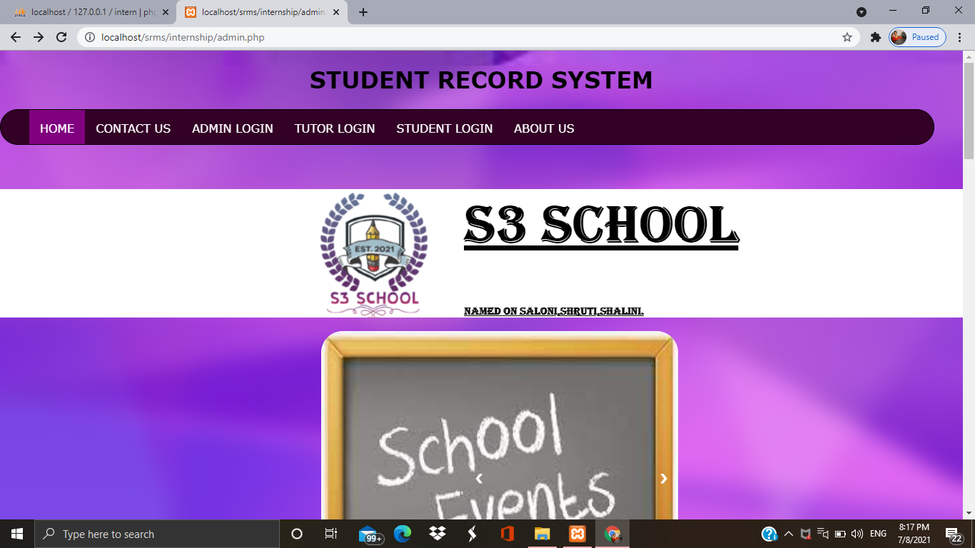

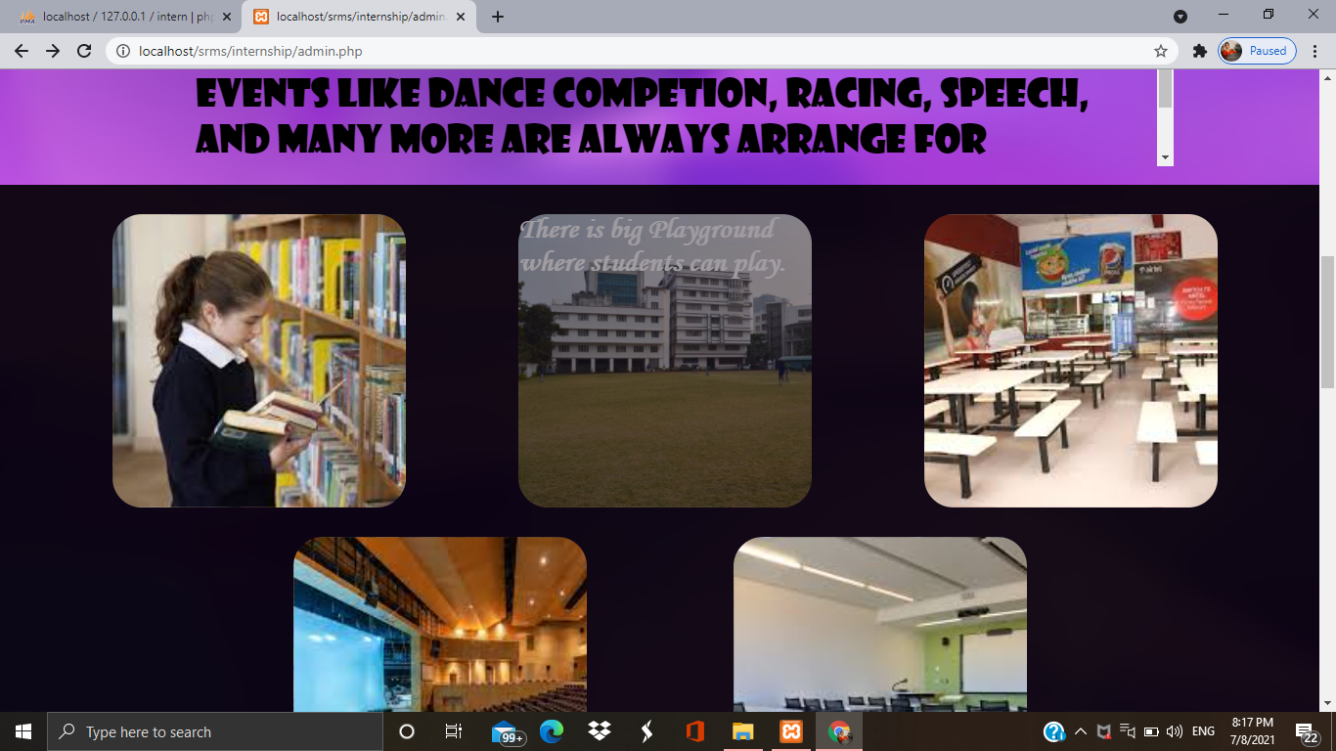

**CONTACT US**

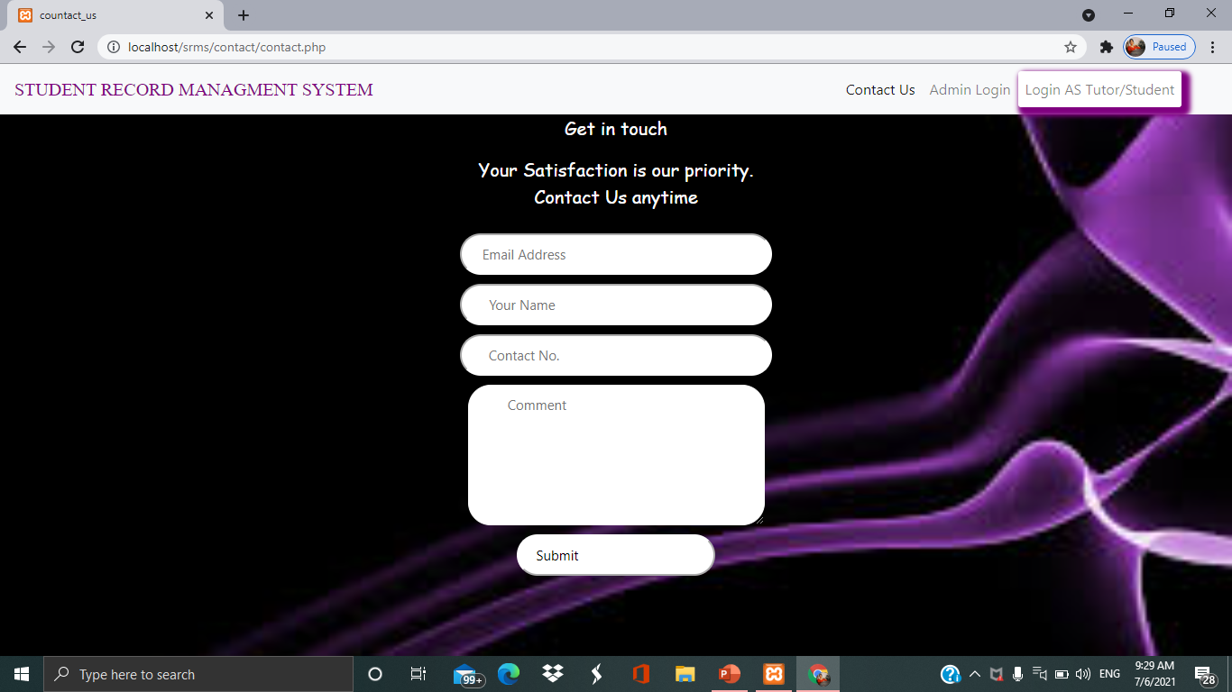

**ABOUT US**

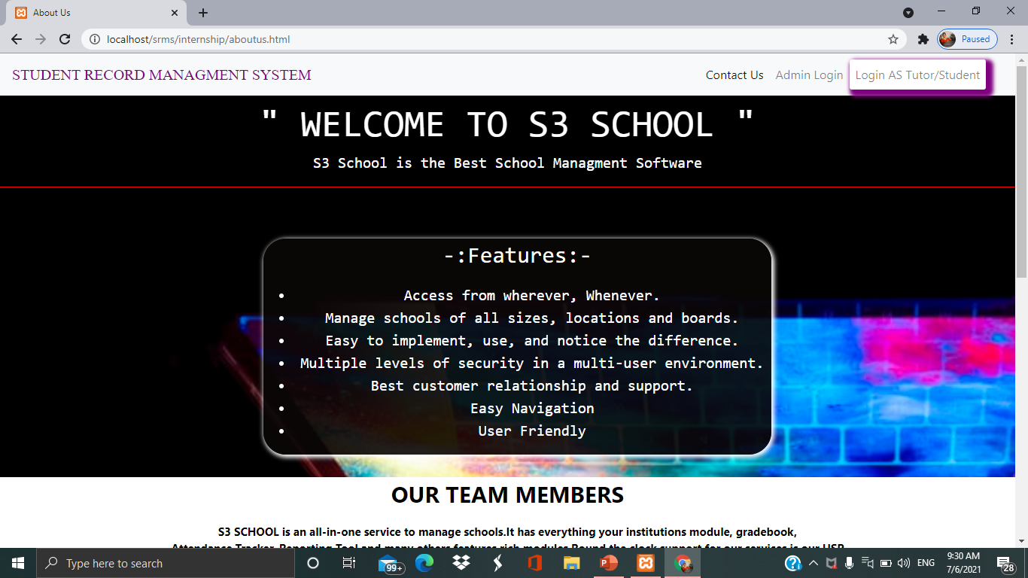

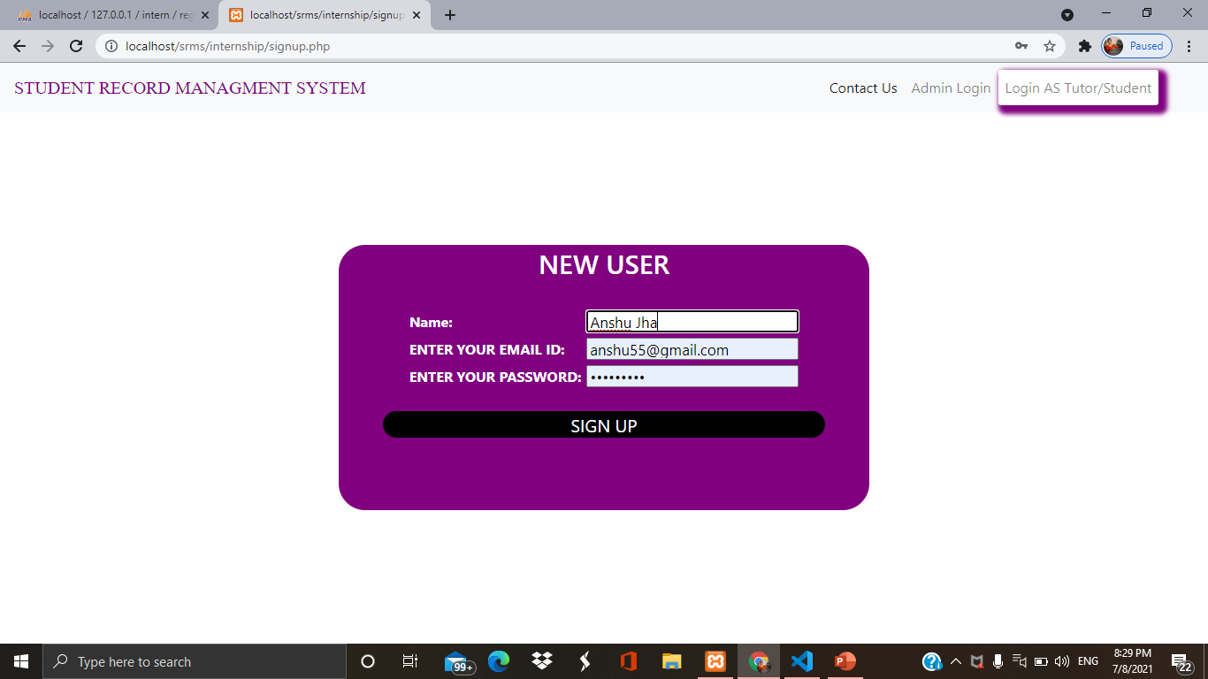**ADMIN SIGNUP**

**ADMIN LOGIN**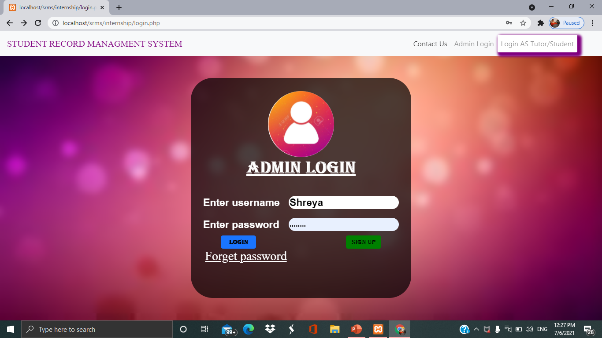

**ADMIN HOME PAGE**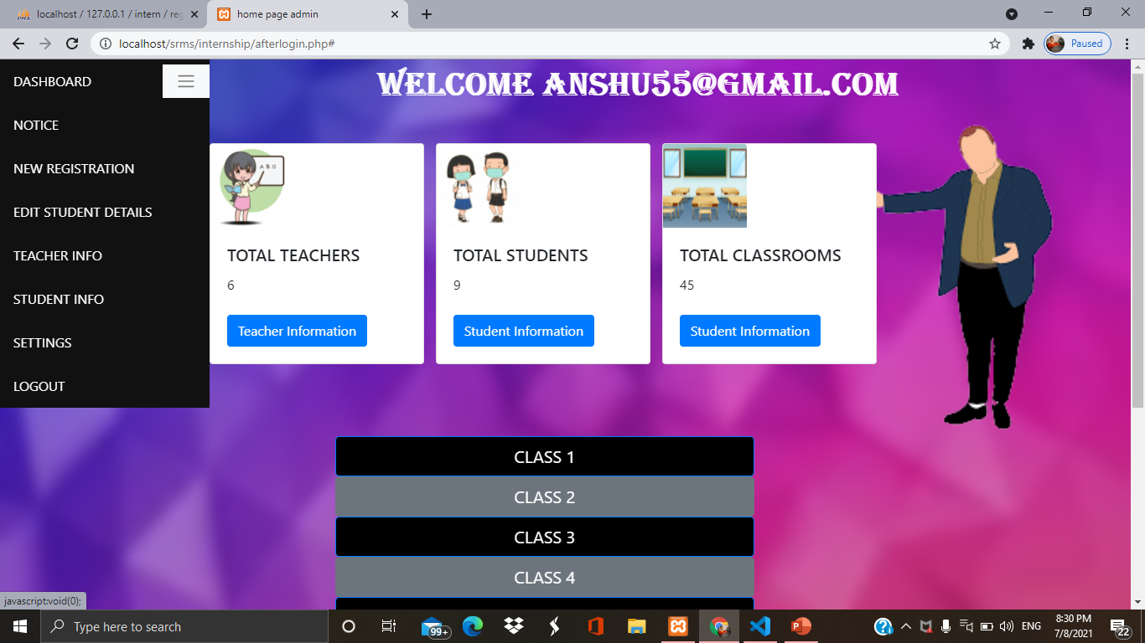

**ADMIN NOTICE**

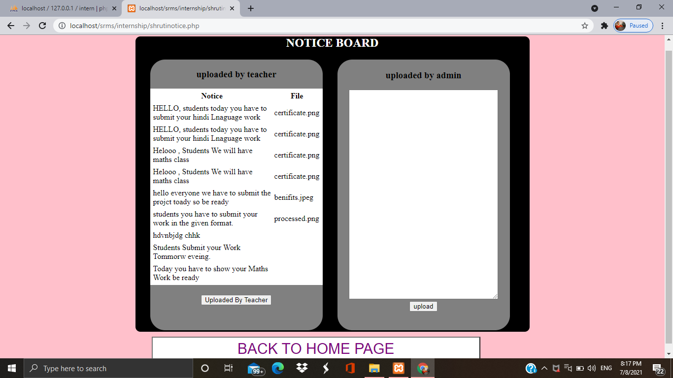

**NEW REGISTRATION**

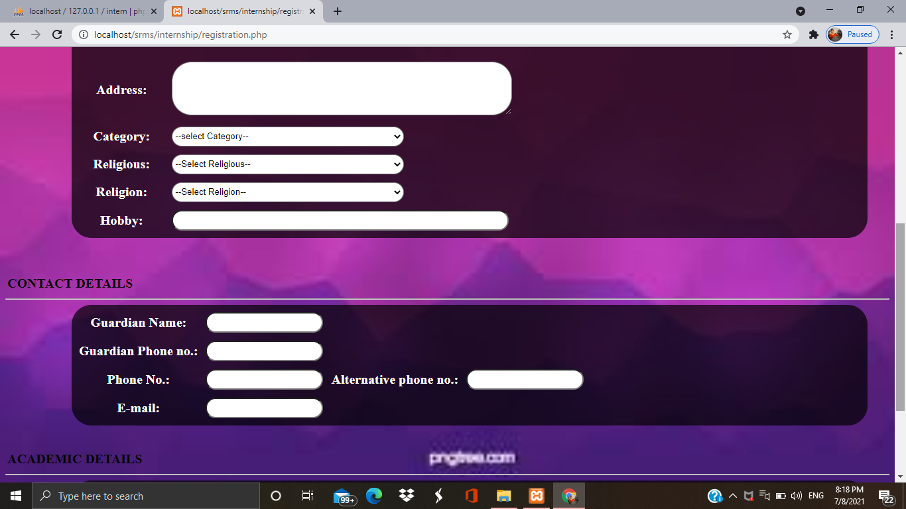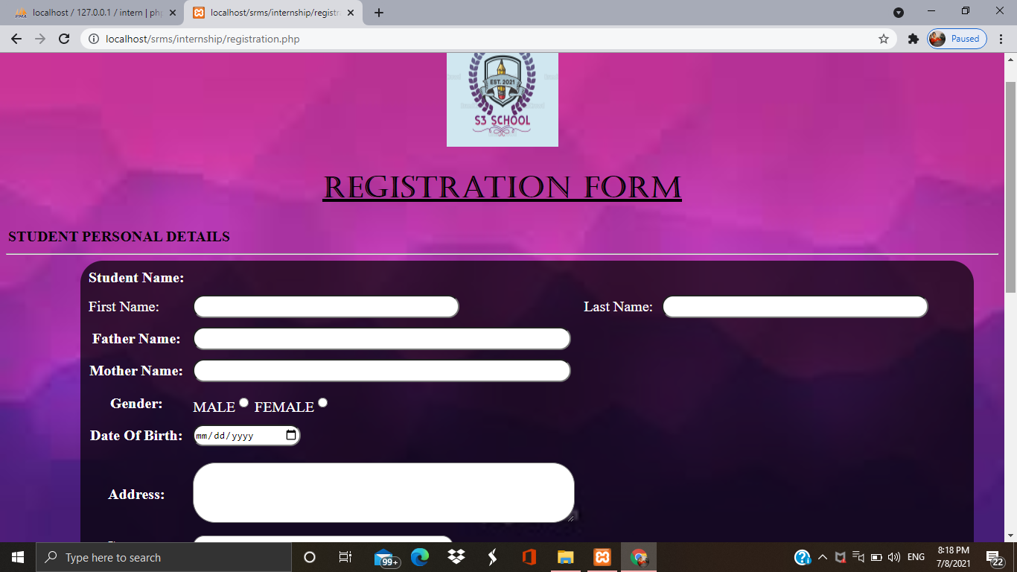

**TEACHERS DETAILS**

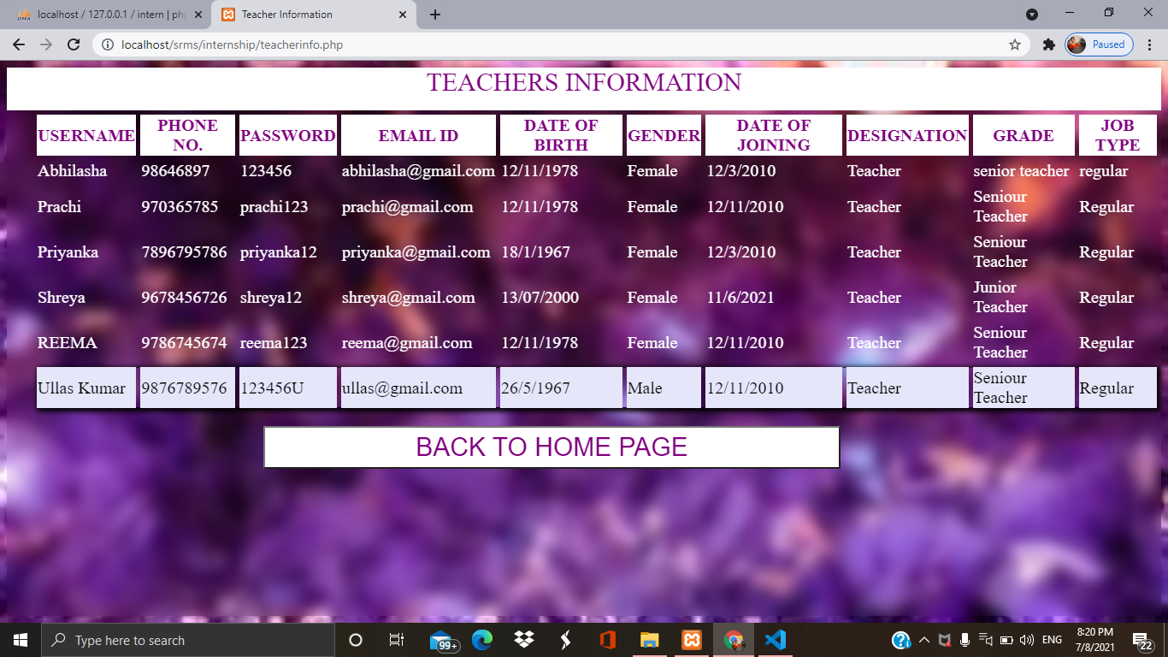

**STUDENT DETAILS**

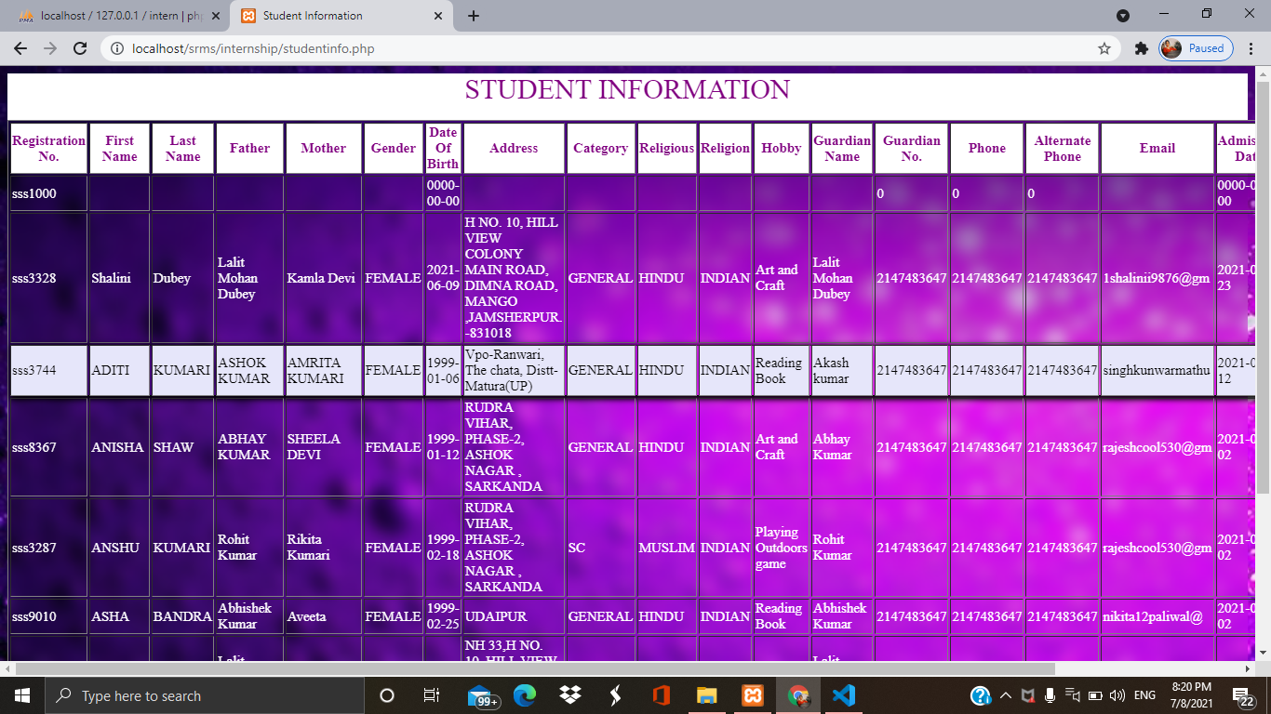

**TUTOR SIGNUP**

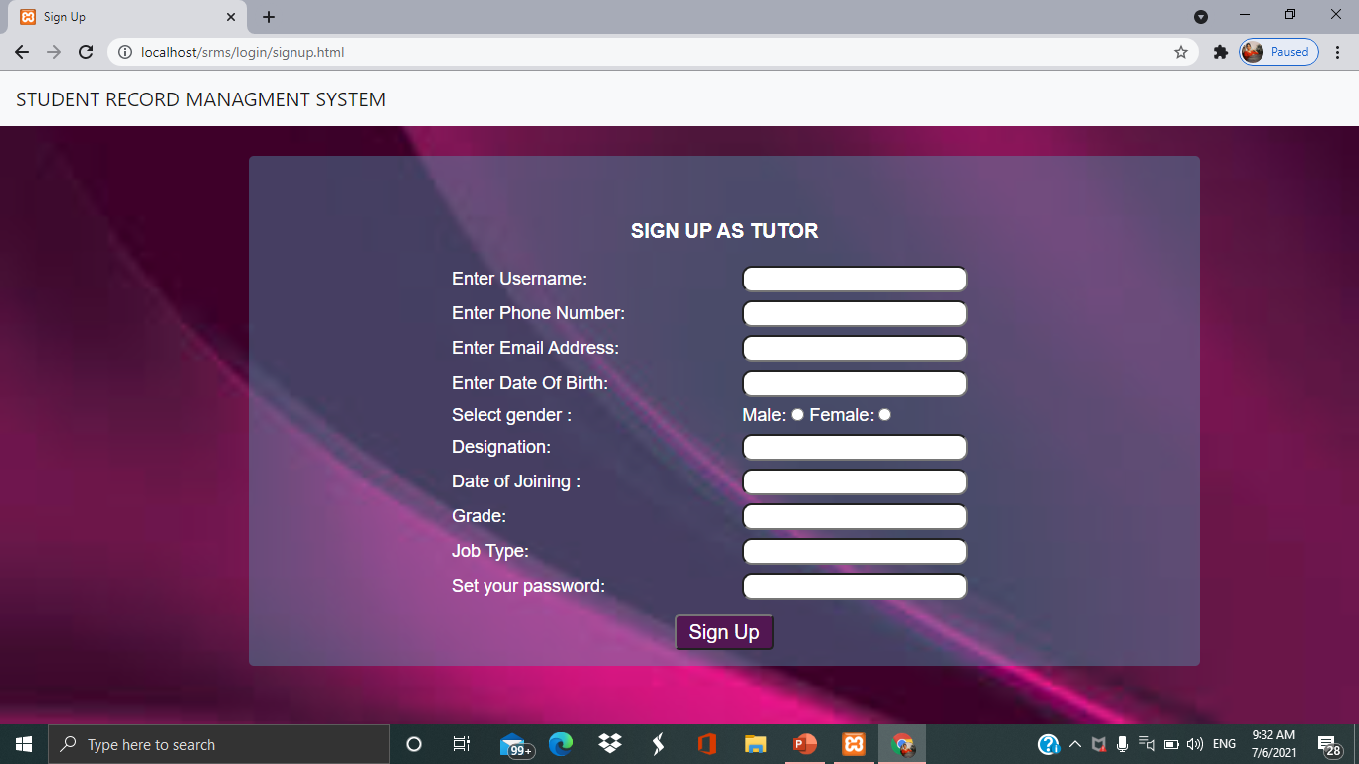

**TUTOR LOGIN**

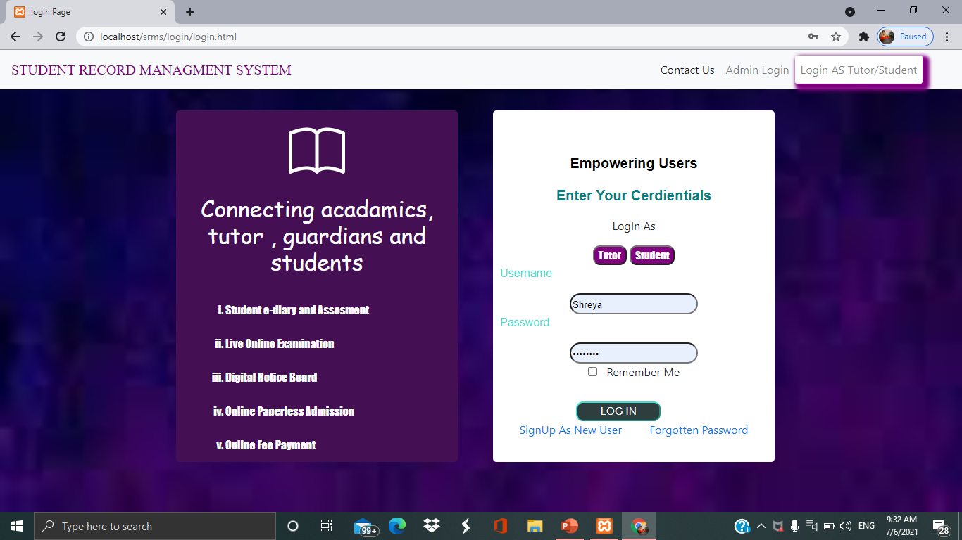

**TUTOR HOME PAGE**

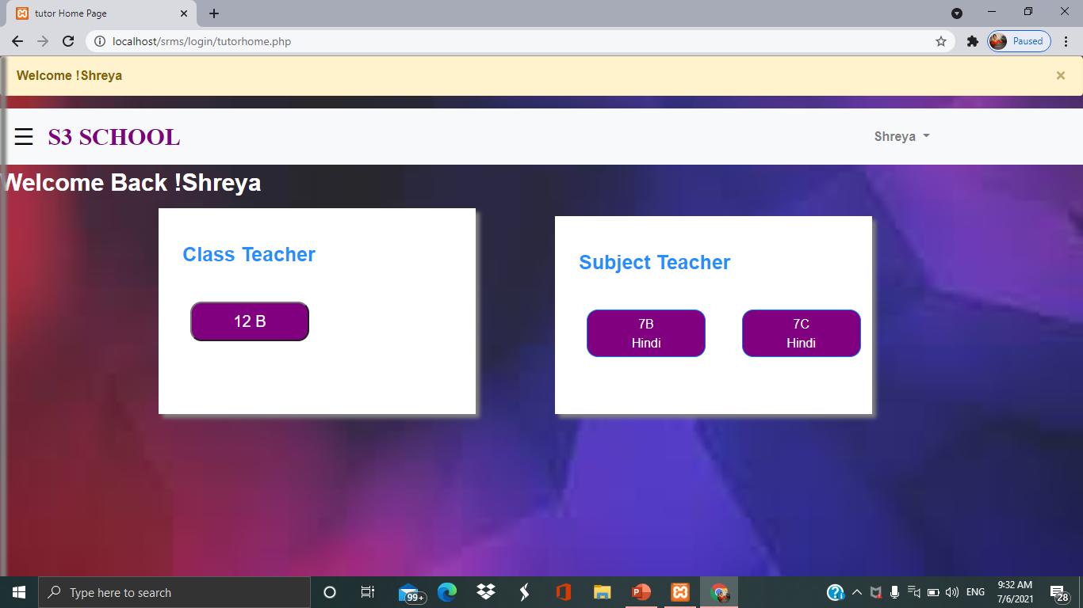

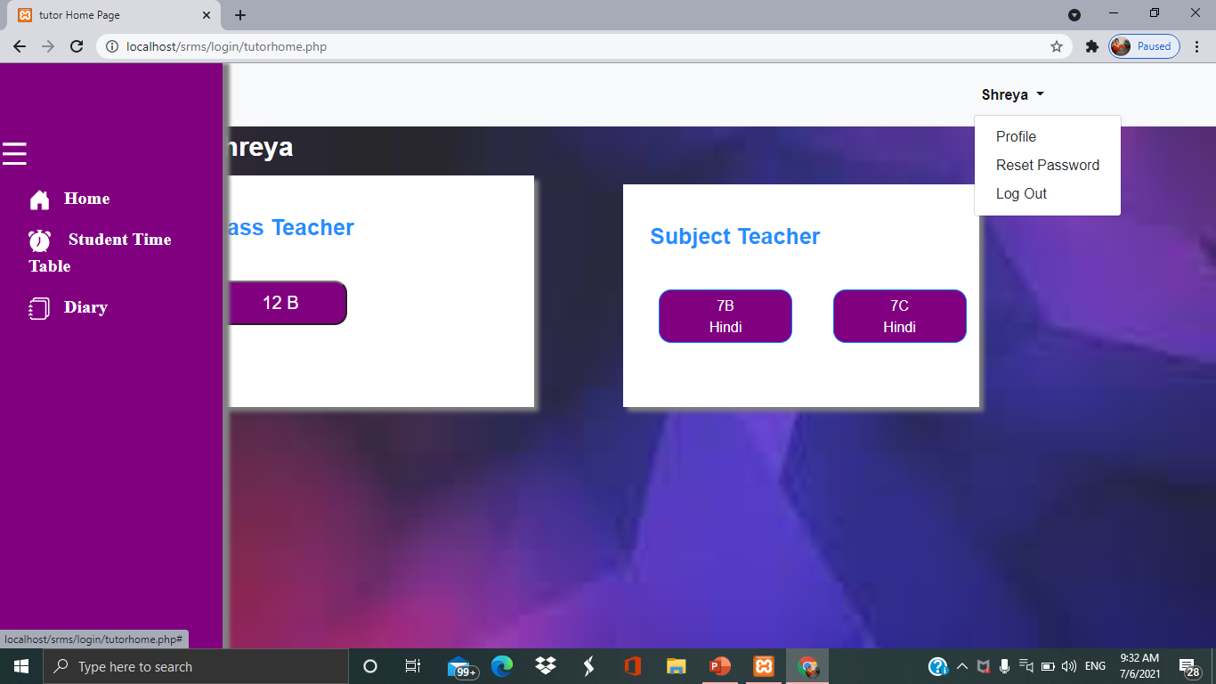

**TUTOR PROFILE**

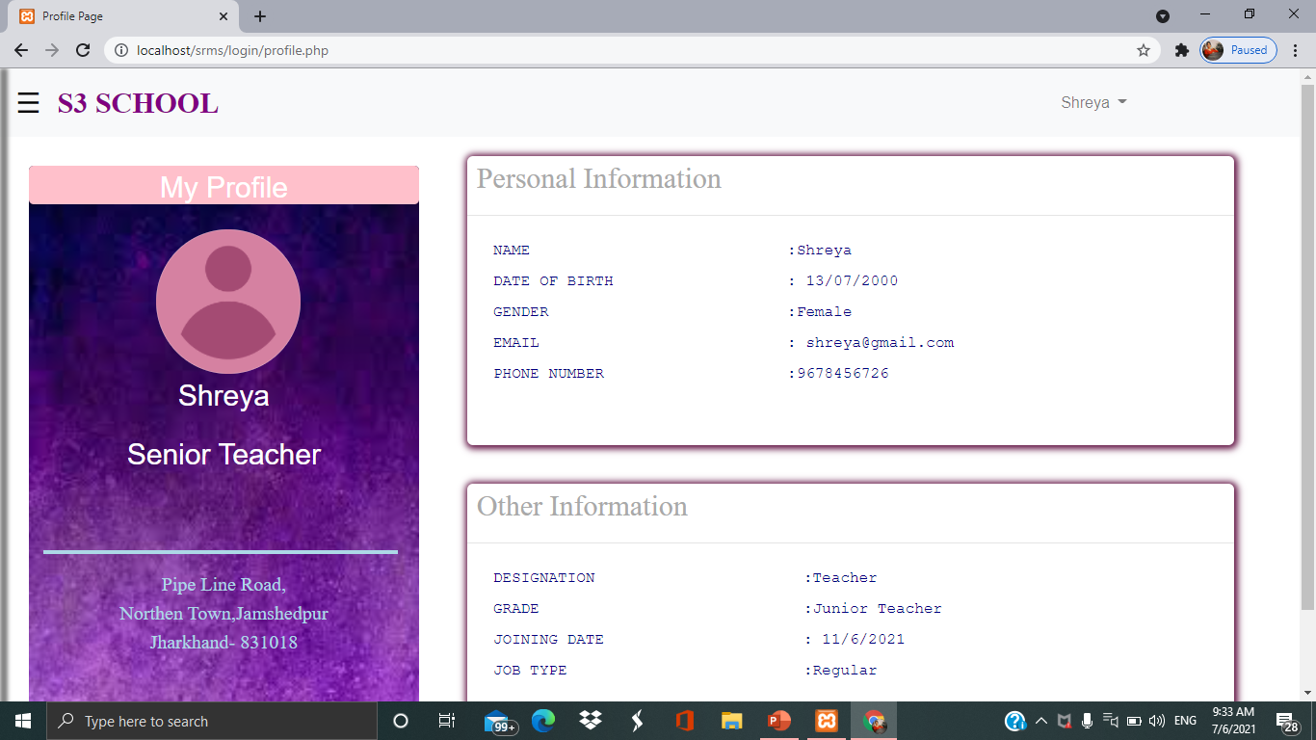

**TUTOR RESET PASSWORD**

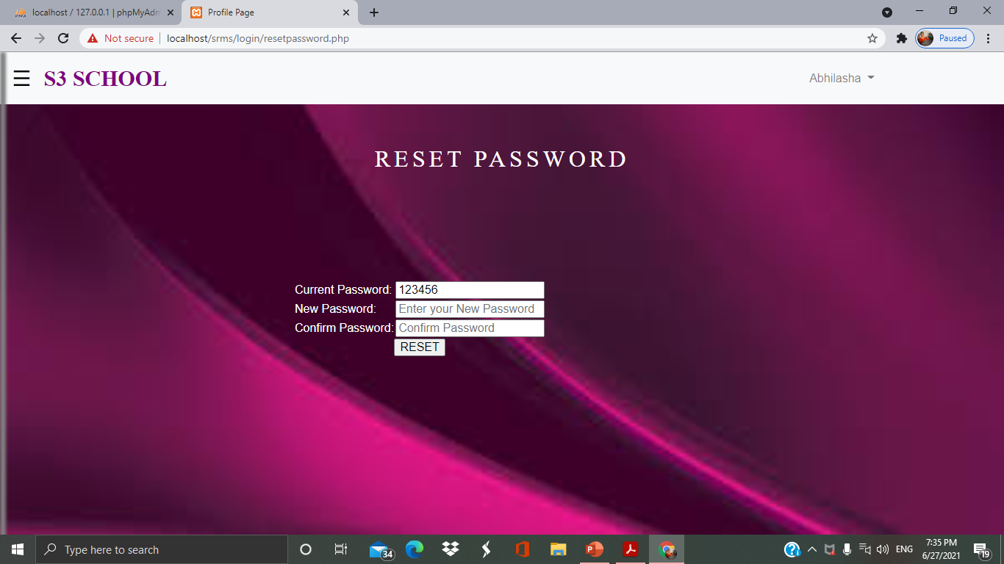

**TUTOR TIME-TABLE**

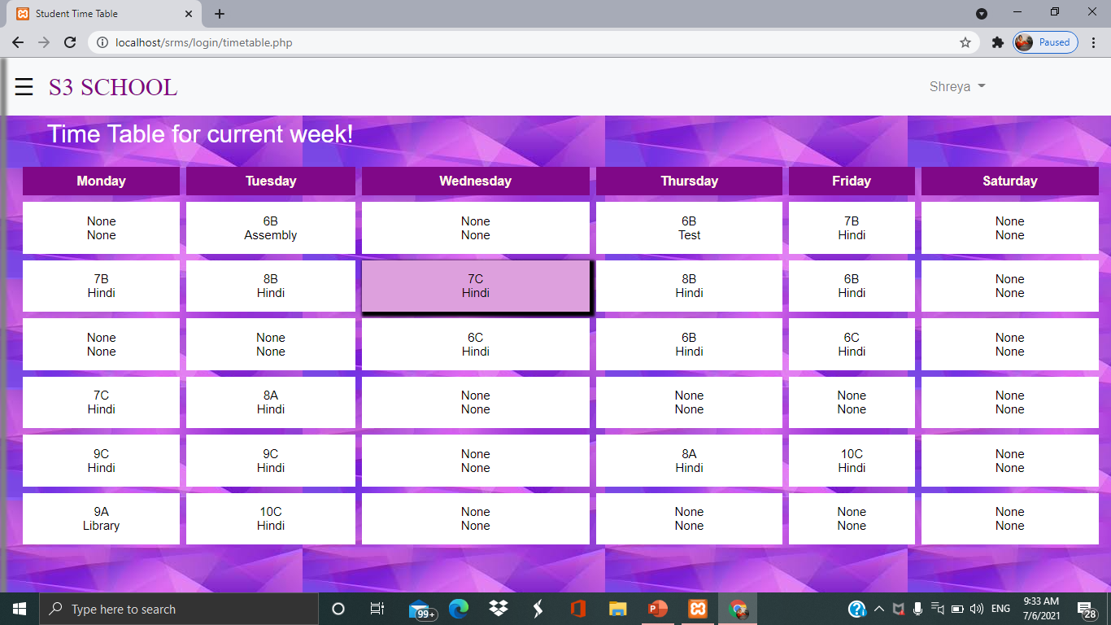

**TUTOR-DIARY**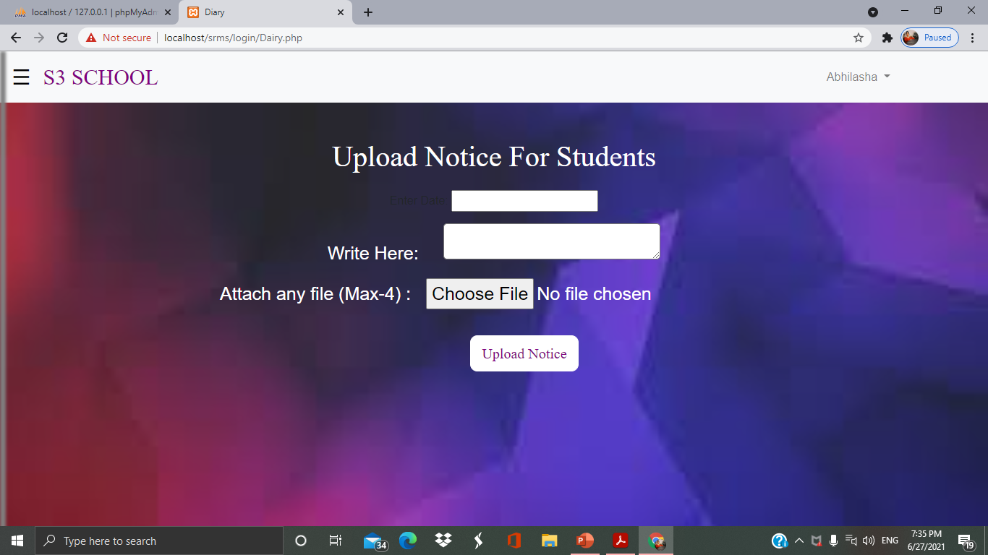

**TUTOR ATTENDANCE**

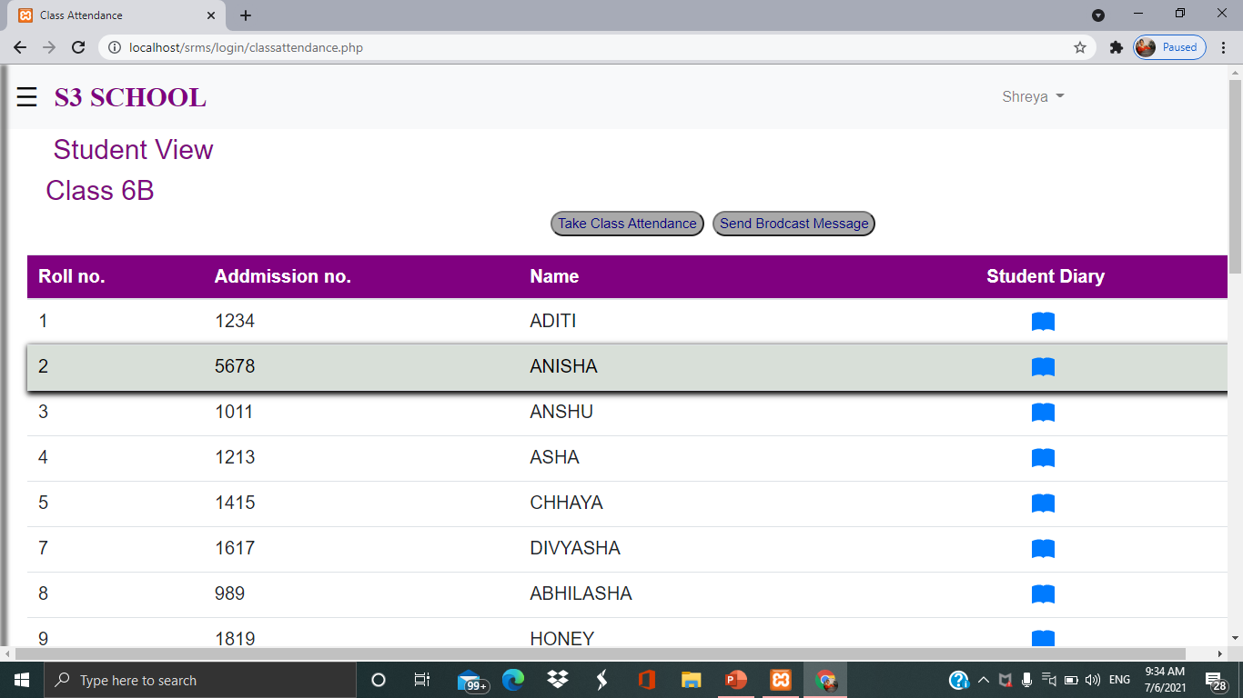

**TAKE CLASS ATTENDANCE**

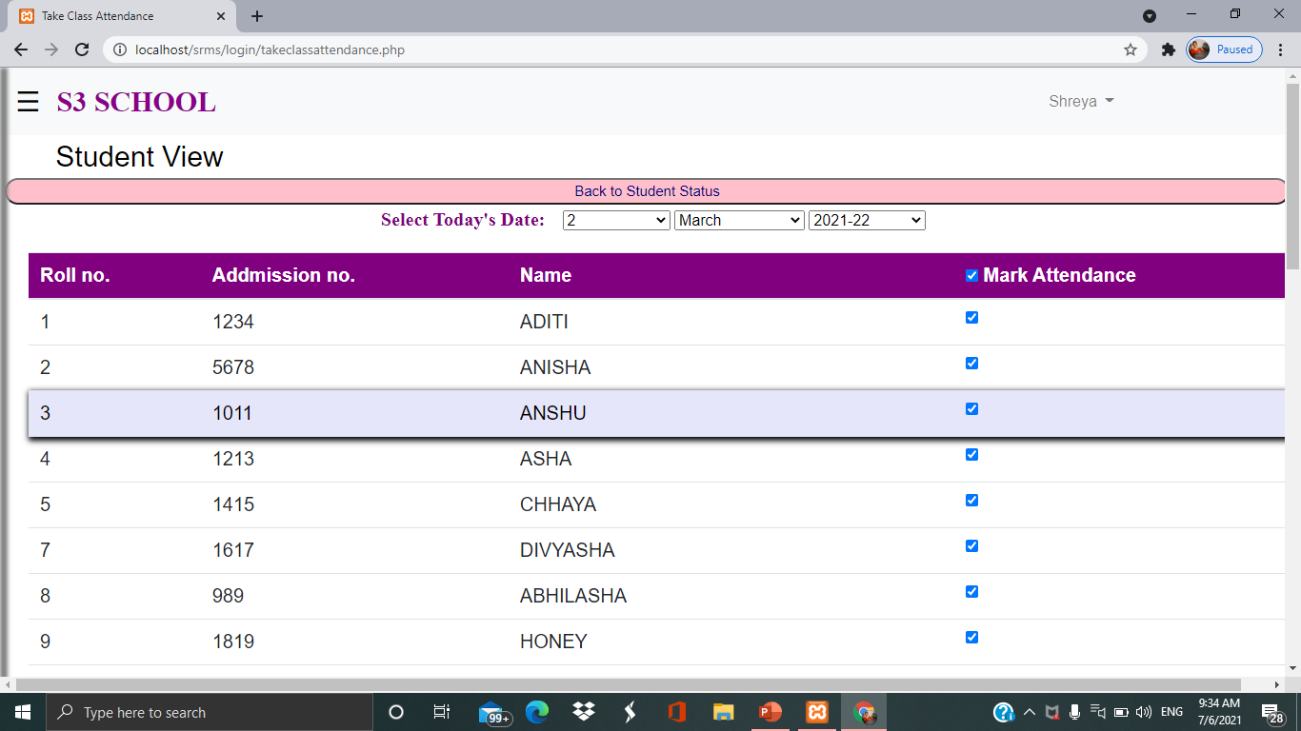

**BROADCAST MESSAGE BY TEACHER TO STUDENTS**

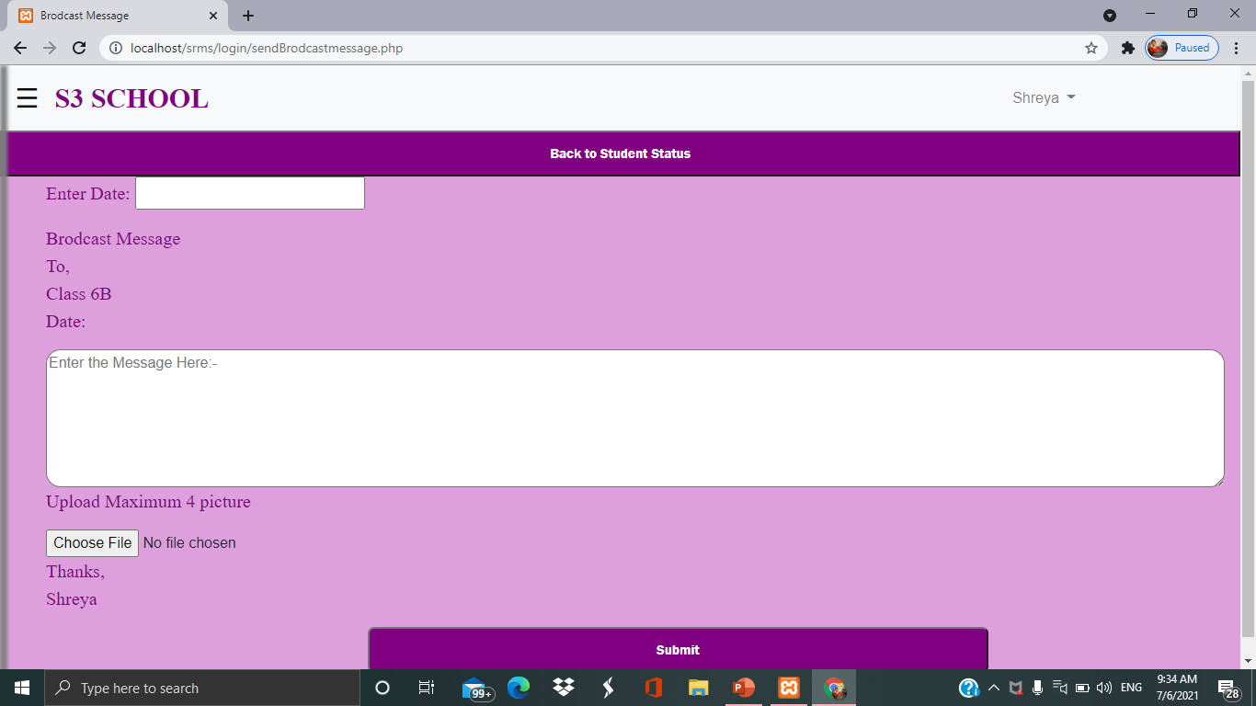

**Attendance of OTHER CLASSES**

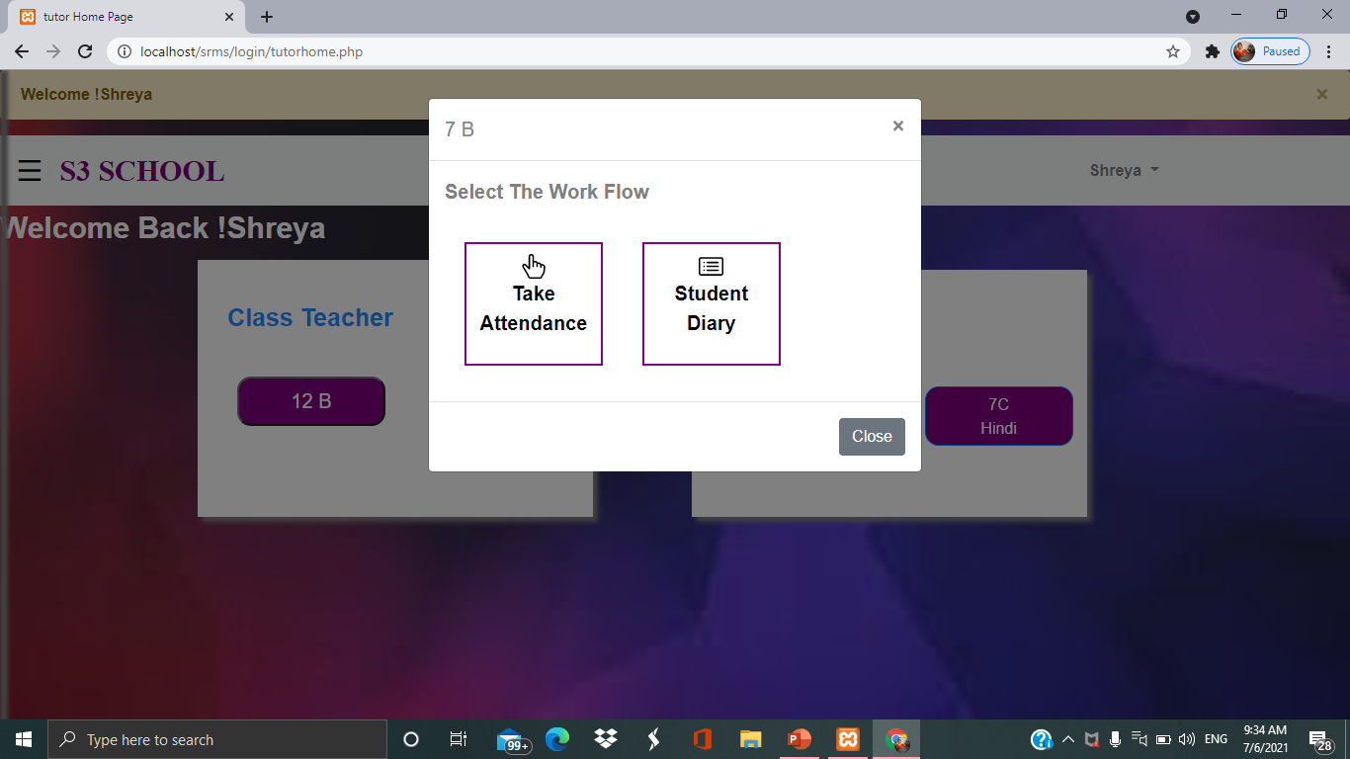

**STUDENT LOGIN**

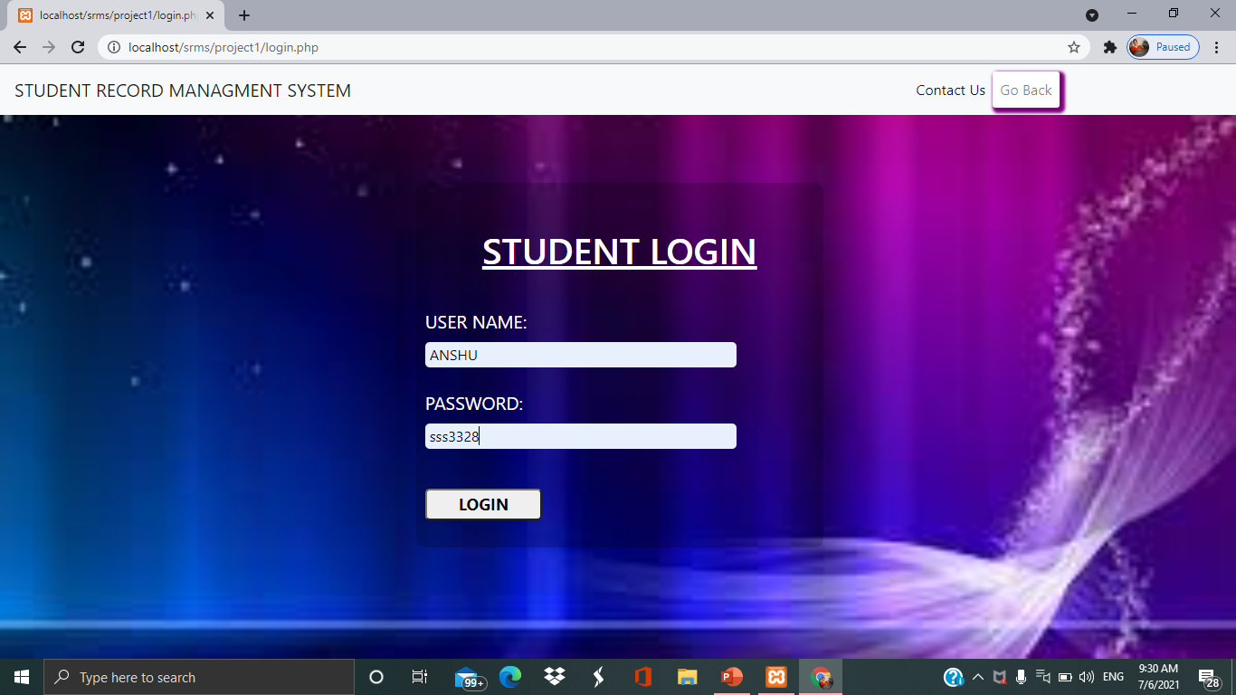

**STUDENT HOME PAGE**

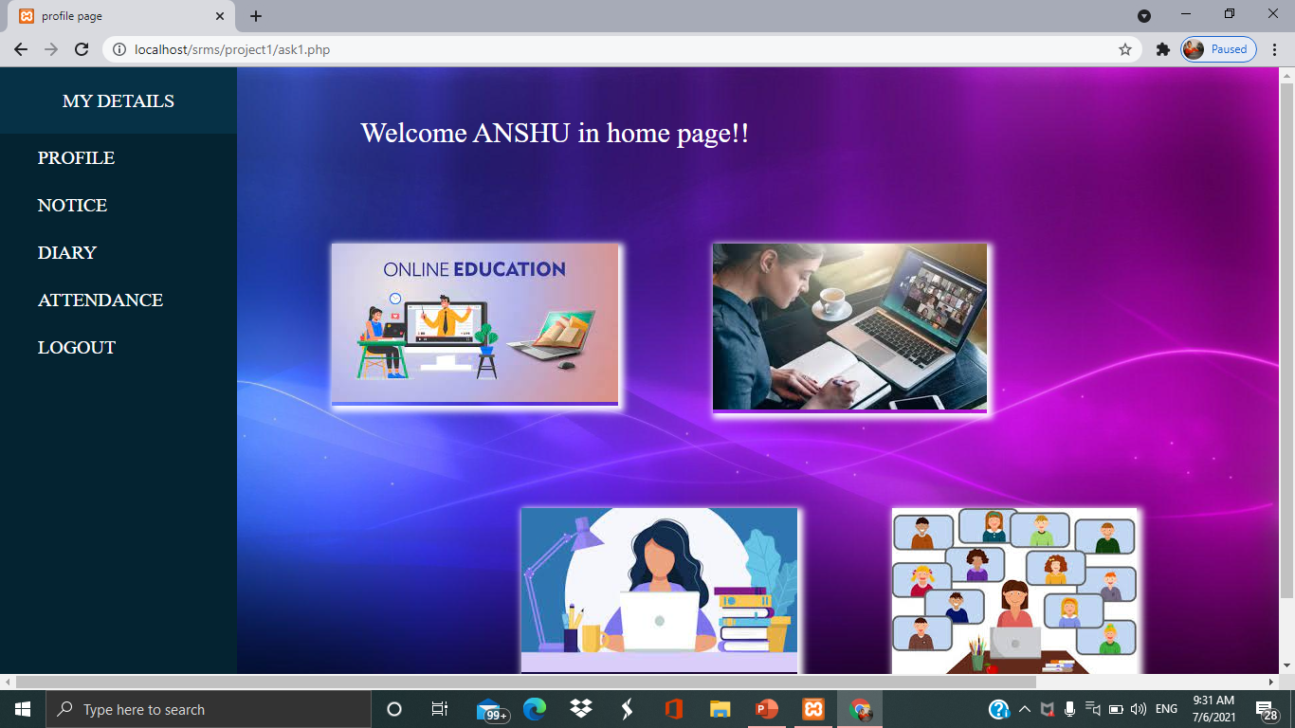

**STUDENT PROFILE**

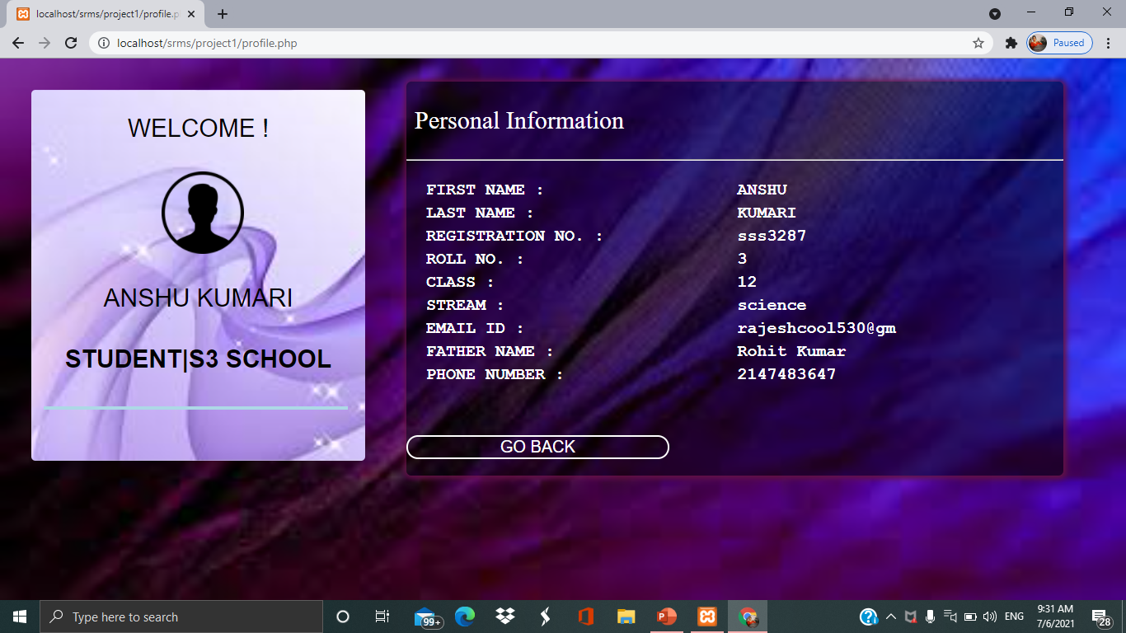

**STUDENT ANNUAL ATTENDANCE REPORT**

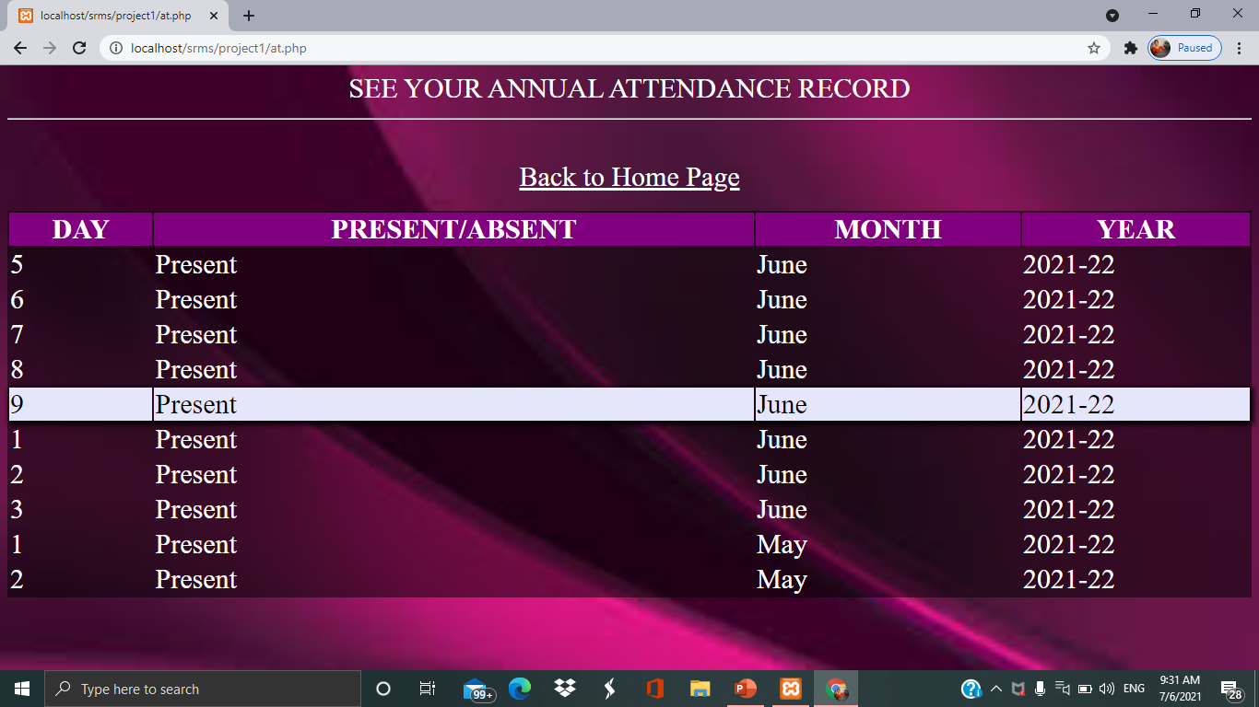

**STUDENT NOTICE**

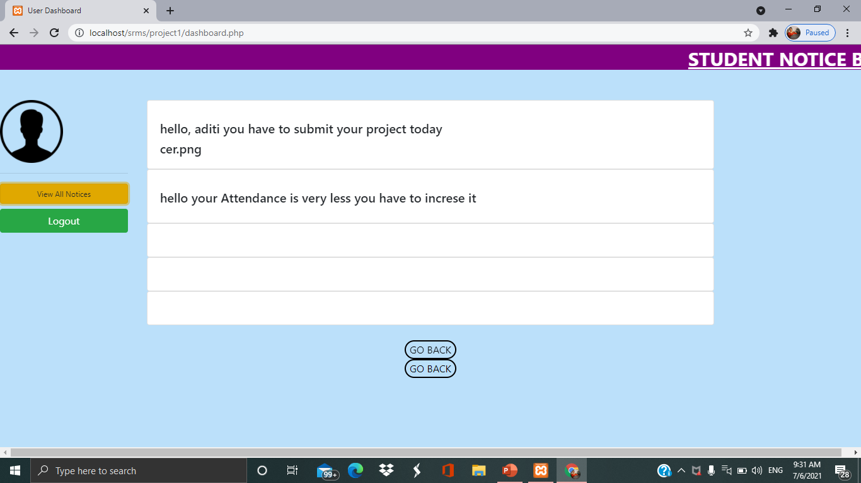

**STUDENT DIARY**

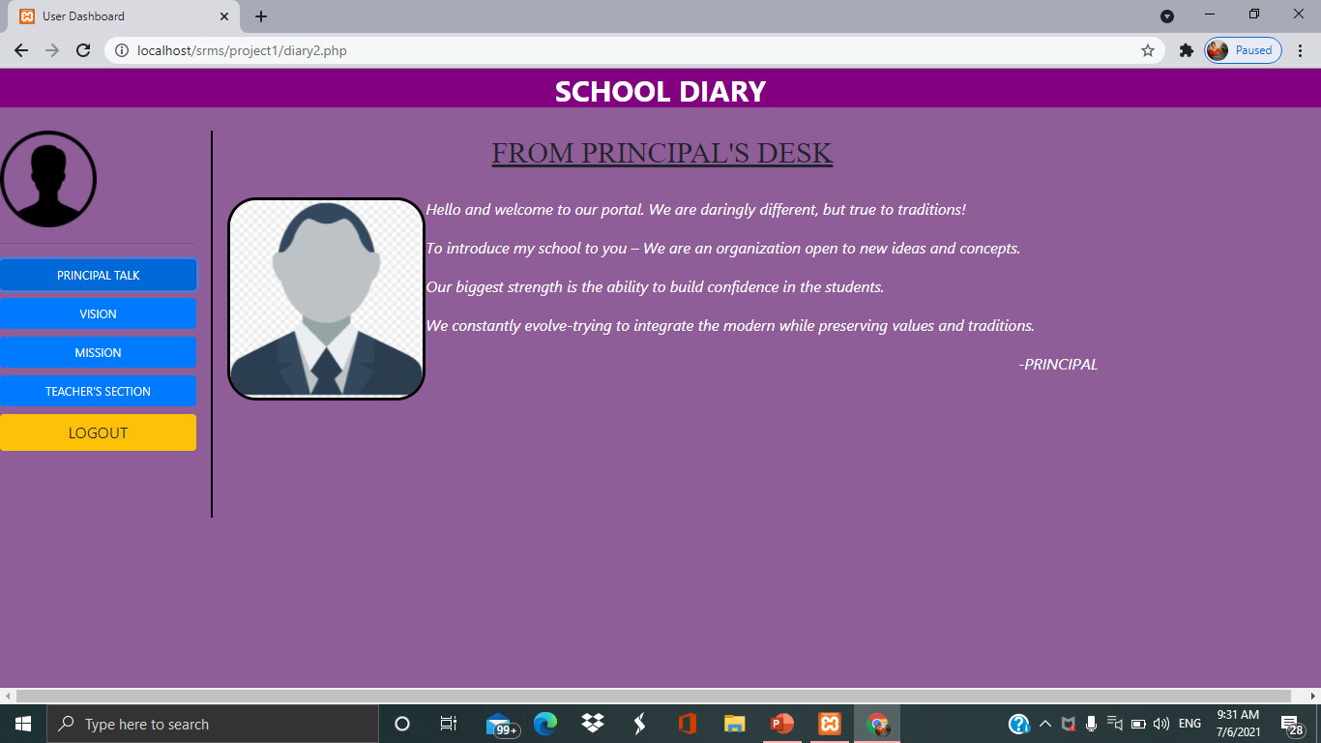

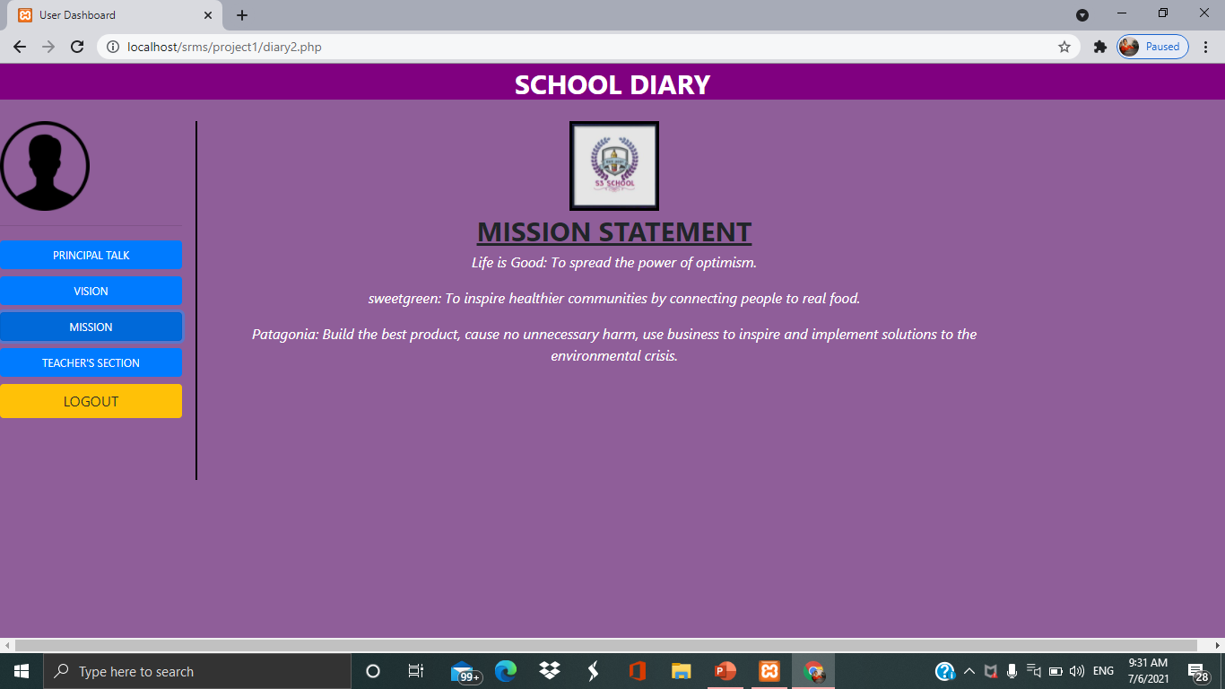

**NOTICE FROM TEACHER**

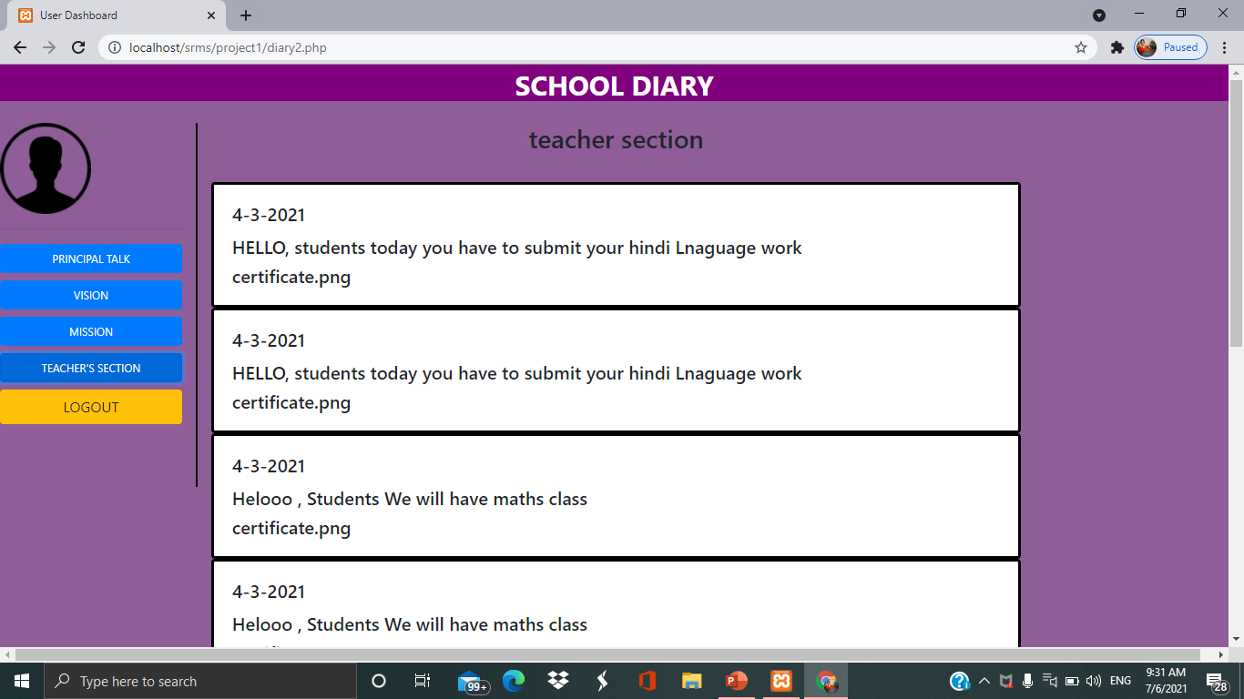

**CODE**

**Home Page**

 <!DOCTYPE html>

<html lang="en" dir="ltr">

  <head>

    <meta name="viewport" content="width=device-width, initial-scale=1.0">

    <title></title> </head>  <body>   <center>

      <h1>STUDENT RECORD SYSTEM</h1></center>

      <ul class="li2">

      <li>  <a class="s1" href="">HOME</a></li>

      <li>  <a href="../contact/contact.php">CONTACT US</a></li>

      <li>  <a href="./login.php">ADMIN LOGIN</a><li>

      <li>  <a href="../login/login.html">TUTOR LOGIN</a><li>

      <li>  <a href="../project1/login.php">STUDENT LOGIN</a><li>

      <li><a href="./aboutus.html">ABOUT US</a></li>

      </ul>

     <div class="shrt">

      <div class="div1">

        <img class="icon" src="newblue.png" alt="">

      </div>

      <div class="div2">  <h2>S3 SCHOOL</h2>

  <h5 style="font-size:15px;margin-bottom:20px;">Named on Saloni,Shruti,Shalini.</h5>   </div>    </div>

    <br>    <div class="slideshow-container">

    <div class="mySlides fade">  <div class="numbertext">1 / 3</div>

  <img id="sl1" class="s1" src="event1.jpg" style="width:500px;height:400px;border-radius: 30px 30px" onmouseover="slitwo()" >

  <div class="text">slide1</div>

</div>

<div class="mySlides fade">  <div class="numbertext">2 / 3</div>

  <img class="s1" src="event2.jpg" style="width:500px;height:400px;border-radius: 30px 30px">  <div class="text">slide Two</div>

</div>

<div class="mySlides fade">

  <div class="numbertext">3 / 3</div>

  <img class="s1" src="event3.jpg" style="width:500px;height:400px;border-radius: 30px 30px">

  <div class="text">slide Three</div>

</div>

<a class="prev" onclick="plusSlides(-1)">&#10094;</a>

<a class="next" onclick="plusSlides(1)">&#10095;</a>

</div>

<br>

<div>

  <span class="dot" onclick="currentSlide(1)"></span>

  <span style="margin:0px;" class="dot" onclick="currentSlide(2)"></span>

  <span style="margin:0px;" class="dot" onclick="currentSlide(3)"></span>

</div></div>

</div><div class="desc">

  <h2 class="fdesc">EVENTS LIKE DANCE COMPETION, RACING, SPEECH, AND MANY MORE ARE ALWAYS ARRANGE FOR STUDENTS REFRESHMENT AND FOR KEEPING THEM ACTIVE.</h2>

</div>

<br>

<div style="background-color:rgba(0,0,0,0.9);width:100%;height:720px;">

  <div class="ndiv1" id="library" onmouseover="lib()" onmouseout="lib2()">

  </div>

  <div class="ndiv2" id="play" onmouseover="play()" onmouseout="play2()">

  </div>

  <div class="ndiv3" id="canteen" onmouseover="cant()" onmouseout="cant2()">

  </div>

  <div style="margin-left:300px"class="ndiv4" id="audi" onmouseover="auditorium()" onmouseout="auditorium2()">

  </div>  <div  style="margin-left:150px" class="ndiv5" id="smart" onmouseover="smarty()" onmouseout="smarty2()">

  </div>   </div>   <div class="div11">

            <p id="heading2"><b><u>01&nbsp;&nbsp;&nbsp;&nbsp;&nbsp;&nbsp;&nbsp;&nbsp;&nbsp;</u></b></p>            <p id="p3"><b>Live Online Examination</b></p>

            <ul id="unlist">                <li class="li1">Effective, efficiant and futuristic way of conducting exams</li>

                <li class="li1">Hassle free and paperless experiance with quick results</li>

                <li class="li1">Simple, secured and transparent mode of exams</li>

            </ul>

        </div>

        <div class="div11"><img style="width: 50%;height: 400px;float: left; " src="onlineexam.jpeg" alt="">

        </div>

        <div class="div12"><img style="width: 50%;height: 400px;float: left; " src="onlinefee.jpeg" alt="">

        </div>

        <div class="div12">

            <p id="heading2"><b><u>02&nbsp;&nbsp;&nbsp;&nbsp;&nbsp;&nbsp;&nbsp;&nbsp;&nbsp;</u></b></p>

            <p id="p3"><b>Online Fee Payment</b></p>

            <ul id="unlist">

                <li>Secured online fee collection with instant receipts</li>

                <li>Advance fee collection with automated reminders</li>

                <li>In depth fee analytics and simplified financial reports</li>

            </ul>

        </div>

        <div class="div11">

            <p id="heading2"><b><u>03&nbsp;&nbsp;&nbsp;&nbsp;&nbsp;&nbsp;&nbsp;&nbsp;&nbsp;</u></b></p>

            <p id="p3"><b>Student e-Dairy</b></p>

            <ul id="unlist">

                <li>Seamless communication with instant notifications</li>

                <li>Secured, cost effective and transparent record keeping</li>

                <li>Digital solution to age old cumbersome practise of physical diary</li>

               </ul>

        </div>

        <div class="div11"><img style="width: 50%;height: 400px;float: left; " src="e-diry.jpeg" alt="">

        </div>

        <footer id="footer1" style="float: left;width:100%;height:fit-content;margin-top:20px;">

            <div class="footerdiv">links <br>Home<br> Privacy Policy</div>

            <div class="footerdiv"> +91-8376527836 <br>support@onlineacadmy.com</div>

            <div class="footerdiv">Get it On <br>Google play</div>

            <p>Copyright 2021 Online Academy All Rights Reserved</p>

        </footer>

 </body>

<style>

   #heading1{

            margin-top: 5px;text-align: center;color: white;font-size: 90px;

            font-family:'Times New Roman', Times, serif;

        }

        #p1{

            margin-top: 5px;            text-align: center;

            color:white;

            font-size: 30px;            font-family:'Times New Roman', Times, serif;

        }

        .div11{

            width: 50%;            height: 400px;

            margin-top: 20px;            padding-left: 30px;

            float: left;        }</style></body></html>

**Admin Sign Up**

<html>    <head> <title> Sign Up </title>       <meta name="viewport" content="width=device-width initial-scale-1.0">script src="../bootstrap/jquery-3.6.0.js"></script> <script src="../bootstrap/bootstrap-4.6.0-dist/js/bootstrap.min.js"></script>

    <link rel="stylesheet" href="../bootstrap/bootstrap-4.6.0-dist/css/bootstrap.min.css">    </head>

    <body

<div id="div1">       <img src="" alt="">

                <p style="color:white;font-size: 20px;font-family: Arial;margin-top: 60px;"><b>SIGN UP AS TUTOR</b></p>

                <form action="./phpfile.php" method="POST">

                  <table cellpadding="4">

                     <tr>

          <td> Enter Username:</td><td><input type="text"name="username"></td>

                     </tr>

                     <tr><td>Enter Phone Number: </td><td><input type="tel" name="phone"></td></tr><tr><td>Enter Email Address: </td>

                        <td> <input type="email" name="email"></td>

                     </tr>

                     <tr><td>Enter Date Of Birth:</td>

                        <td><input type="varchar" name="DOB"></td>

                     </tr>

                     <tr> <td>Select gender :</td>

                        <td>Male: <input type="radio" name="gender" value="Male">Female: <input type="radio" name="gender" value="Female"><br></td>

                     </tr>

                     <tr><td>Designation: </td><td><input type="text" name="designation"></td></tr> <tr>

                        <td> Date of Joining :</td>

                        <td><input type="varchar" name="DateOfJoining"></td>

                     </tr><tr>

                        <td>Grade: </td>

                        <td><input type="text" name="grade"></td>

                     </tr> <tr>

                        <td>Job Type: </td>

                        <td><input type="text" name="jobtype"></td>

                     </tr>tr>

                        <td>Set your password:</td>

                        <td><input type="text" name="password"></td>

                     </tr></table>

          <input type="submit" name="subsign" value="Sign Up" id="signup">

</form></div>

        <style>

           #signup{

              width: 100px;

              height: fit-content;

              margin-top: 10px;

              border-radius: 5px;

              background-color: rgb(82, 23, 82);

              color: white;

              font-size:20px;

              font-family:sans-serif;

           }

<script>

function checkboxclick()

            {

         document.getElementById("rememberme").style.backgroundColor="blue";

            }

            function click()

            {

         document.getElementById("button1").style.backgroundColor="blue";

            }

        </script>

          </body>

          </html>

**Admin Login**

<html>

  <head>

    <meta charset="utf-8">

    <meta name="viewport" content="width=device-width initial-scale-1.0">

    <script src="../bootstrap/jquery-3.6.0.js"></script>

    <script src="../bootstrap/bootstrap-4.6.0-dist/js/bootstrap.min.js"></script>

    <link rel="stylesheet" href="../bootstrap/bootstrap-4.6.0-dist/css/bootstrap.min.css">

    <title></title>

<body><center>

  <nav class="navbar navbar-expand-lg navbar-light bg-light">

            <a class="navbar-brand" href="#" style="color:#800080;font-family: Franklin;font-size: 20px ;">STUDENT RECORD MANAGMENT SYSTEM</a>

            <button class="navbar-toggler" type="button" data-toggle="collapse"data-target="#navbarNavAltMarkup" aria-controls="navbarNavAltMarkup" aria-expanded="false" aria-label="Toggle navigation"><span class="navbar-toggler-icon"></span>

            </button><div class="collapse navbar-collapse" id="navbarNavAltMarkup" style="margin-left:500px;">

              <div class="navbar-nav"><a class="nav-link active" href="../contact/contact.php">Contact Us<span class="sr-only">(current)</span></a>a class="nav-link" href="../internship/login.php">Admin Login</a>

                <div style="border-radius: 3px;box-shadow:5px 5px 5px 5px purple; background-color:white;">

                    <a class="nav-link" href="../login/login.html">Login AS Tutor/Student</a></div>

              </div></div>

    </nav>form action="#" method="POST">

      <center>

        <img src="icon.png" alt="">

         <h1><b><u>ADMIN LOGIN</u></b></h1></center><table cellpadding="10">

        <tr><td><b>Enter username</b></td><td><input class="in" type="text" name="t1" value=""></td> </tr>

        <td><b>Enter password</b></td><td><input class="in" type="password" name="t2" value=""></td></table><input class="log1" type="submit" name="sub" value="LOGIN">

         <a href="signup.php"><button class="log"type="button" name="button">SIGN UP</button></a>

         <a href="forgot.html"><h3 style="font-family:none;color:white;margin-right:250px;"><u>Forget password</u></h3></a>

         </a>

         </center>

      </form>

  </body>

</html>

 <?php

   session_start();

   $conn=mysqli_connect("localhost","root","","intern");

   if (isset($_POST["sub"])) {

  $user=$_POST["t1"];

  $pass=$_POST["t2"];

  $sql="select * from signup where username='$user' and password='$pass'";

  $result=mysqli_query($conn,$sql);

  $row=mysqli_fetch_row($result);

  if ($row>0)

   {

    $_SESSION["t2"]=$row[2];

    header("location:afterlogin.php");

    }

   else {

   echo "<script>";

   echo "alert('wrong password')";

    echo "</script>";

    echo mysqli_error($conn);

   }

   }

?>

**Admin Home Page**

<?php

session_start();

if ($_SESSION['t2']) {

echo "Welcome"." "." ".$_SESSION['t2'];

}

else{

header('location:login.php');

}

?> </div><div style="float:left"> <img onclick="dis()" style="height:400px;margin-left:490px;" src="wel2.png" alt="">

</div>

</div>

<html lang="en" dir="ltr">

  <head>

  <meta name="viewport"

      content="width=device-width, initial-scale=1">

      <script src="../bootstrap/jquery-3.6.0.js"></script>

      <script src="../bootstrap/bootstrap-4.6.0-dist/js/bootstrap.min.js"></script>

      <link rel="stylesheet" href="../bootstrap/bootstrap-4.6.0-dist/css/bootstrap.min.css">

    <link rel="stylesheet" href=ss"https://cdnjs.cloudflare.com/ajax/libs/font-awesome/4.7.0/css/font-awesome.min.css">

    <title>

      home page admin

    </title>

<script type="text/javascript">

      function shrutiaf() {

      var x = document.getElementById("menus");

      if (x.style.display === "none") {

           x.style.display = "block";

         } else {

          x.style.display = "none";

        }

      }

  // Function to toggle the plus menu into minus

    function myFunction(x) {

      x.classList.toggle("fa-minus-circle");

    }

    //not displaying alert

    function dis() {

      document.getElementById("hu3").style.display = "block";

    }

    //closing icon of alert

    function sp2(){

      document.getElementById("hu3").style.display = "none";

    }

    function setting1() {

      document.body.style.backgroundImage="url('sdetailback.jpg')";

    }

</script>

</head>

  <body>

   <div class="menu-list">

      <!-- Logo and navigation menu -->

      <div class="shruti">

        <a href="#"class="">DASHBOARD</a>

        <div id="menus">

          <a href="shrutinotice.php">NOTICE</a>

          <a href="registration.php">NEW REGISTRATION</a>

          <a href="edit.php">EDIT STUDENT DETAILS</a>

          <a href="teacherinfo.php">TEACHER INFO</a>

         <a href="studentinfo.php">STUDENT INFO</a>

          <a class="set" onclick="setting1()" >SETTINGS</a>

          <a href="logout.php">LOGOUT</a>

      </div><div style="padding:0px;">

      <!-- Bar icon for navigation -->

        <a style="padding:0px;margin-top:6px;" href="javascript:void(0);" class="icon"

            onclick="shrutiaf()">

  <nav class="navbar navbar-light bg-light"> <span class="navbar-toggler-icon"></span></nav>

   </a></div>

      </div>

    </div>

<div class="card" style="width:16rem;position:absolute;margin-left:250px;margin-top:100px">

  <img style="width:100px;height:100px" src="teachercount.jpg" class="card-img-top" alt="wrong path">

  <div class="card-body">

    <h5 class="card-title">TOTAL TEACHERS</h5>

    <?php

  // Setting up connection with database project

  $connection = mysqli_connect("localhost", "root", "","project");

  // Check connection

  if (mysqli_connect_errno())

  {

    echo "Database connection failed.";

  }

$query = "SELECT phone FROM signup";

  $result = mysqli_query($connection, $query);

 if ($result)

      $row = mysqli_num_rows($result);

    if ($row)

      {

        echo "$row";

      }

    // close the result.    mysqli_free_result($result);

  }

  // Connection close

  mysqli_close($connection);

?>

<br><br>

    <a href="teacherinfo.php" class="btn btn-primary">Teacher Information</a>

  </div>

</div>

<div class="card" style="width:16rem;position:absolute;margin-left:520px;margin-top:100px">

  <img style="width:100px;height:100px" src="studentcount.jpg" class="card-img-top" alt="wrong path">

  <div class="card-body">

    <h5 class="card-title">TOTAL STUDENTS</h5>

    <?php

  // Setting up connection with database project

  $connection = mysqli_connect("localhost", "root", "", "intern");

  if (mysqli_connect_errno())

  {

    echo "Database connection failed.";

  }

  $query = "SELECT category FROM reg";

  $result = mysqli_query($connection, $query);

  if ($result)

  {

    $row = mysqli_num_rows($result);

    if ($row)

      {

        echo "$row";

      }

    mysqli_free_result($result);

  }

  mysqli_close($connection);

  ?>

**New Registration**

<!DOCTYPE html>

<html lang="en" dir="ltr">

  <head>

    <meta charset="utf-8">

    <title></title>

<body>

    <form action="#" method="post">

  <a href="afterlogin.php" >  <button type="button" name="button">Back to Home page</button></a>

   <center>

  <img src="blue.png" alt="">

  <h1><u>Registration Form</u></h1></center>

    <table>

  <tr>

  <td><label><b>STUDENT PERSONAL DETAILS</b></label></td></tr>

<hr>

<div class="shruti">

  <table cellspacing="10">

    <tr>

      <th>Student Name:</th>

      </tr>

      <tr>

        <td><label>First Name:</label></td>

        <td><input type="text" name="fname" value="" style="width:350px"></td>

        <td><label>Last Name:</label></td>

        <td><input type="text" name="lname" value="" style="width:350px"></td>

      </tr>

      <tr>

        <th>Father Name:</th>

        <td><input type="text" name="fathername" value="" style="width:500px"></td>

      </tr>

      <tr>

        <th>Mother Name:</th>

        <td><input type="text" name="mothername" value=""style="width:500px"></td>

      </tr><tr>

        <th>Gender:</th>

        <td>MALE<input type="radio" name="r1" value="MALE">

          FEMALE<input type="radio" name="r1" value="FEMALE">

          </td>

        </tr>

        <tr>

            <th>Date Of Birth:</th>

              <td><input type="date" name="dob" value=""></td>

            </tr><tr>

                  <tr>

                      <th>Address:</th>

                      <td><textarea name="address" rows="5" cols="70"></textarea>

                       </td>

                   </tr>

                 <tr>

        <th>Category:</th>

        <td><select class="" name="category">

           <option value="--select category--">--select Category--</option>

            <option value="GENERAL">GENERAL</option>

            <option value="ST">ST</option>

            <option value="SC">SC</option>

            <option value="OBC">OTHER</option>

        </select></td>

      </tr>

        <th>Religious:</th>

        <td><select class="" name="regis">

          <option value="--Select Religious--">--Select Religious--</option>

          <option value="HINDU">HINDU</option>

          <option value="MUSLIM">MUSLIM</option>1

          <option value="CHRISTIAN">CHRISTIAN</option>

        </select></td>

      </tr>

      <tr>

        <th>Religion:</th>

        <td><select class="" name="relin">

          <option value="--Select Religion--">--Select Religion--</option>

          <option value="INDIAN">INDIAN</option>

          <option value="">FHGJJ</option>

          <option value="">HFHVHBHN</option>

        </select></td>

      </tr>

      <tr>

        <th>Hobby:</th>

        <td><input type="text" name="hobby" value=""style="width:500px"></td>

      </tr>

    </table>

   </div>

   <br>

   <br><br>

   <table>

  <tr>

  <td><label><b>CONTACT DETAILS</b></label></td></tr>

   </table>

   <hr>

   <div class="shruti">

  <table cellspacing="10">

   <tr>

  <th>Guardian Name:</th>

  <td><input type="text" name="gname" value="">

  </td>

</tr>

<tr>

  <th>Guardian Phone no.:</th>

  <td><input type="text" name="guardianno" value="">

  </td>

</tr>

    <tr>

      <th>Phone No.:</th>

      <td><input type="text" name="phone" value="">

      </td>

      <th>Alternative phone no.:</th>

      <td><input type="text" name="alt" value="">

      </td>

    </tr>

    <tr>

</table>

</table>

<center>

  <input style="border-radius:0px" type="submit" name="sub" value="SUBMIT">

  <input style="border-radius:0px" type="submit" name="button" value="SAVE & RETURN LATER">

</form>

  </body>

</html>

<?php

$conn=mysqli_connect("localhost","root","","intern");

if (isset($_POST["sub"]))

{

$fname=$_POST["fname"];$lname=$_POST["lname"];$father=$_POST["fathername"];

$mother=$_POST["mothername"];$gender=$_POST["r1"];

$dob=$_POST["dob"];$address=$_POST["address"];

$category=$_POST["category"];$religious=$_POST["regis"];

$religion=$_POST["relin"];$hobby=$_POST["hobby"];

$gname=$_POST["gname"];$gno=$_POST["guardianno"];

$phone=$_POST["phone"];$altnum=$_POST["alt"];

$email=$_POST["email"];$admissiondate=$_POST["admissiondate"];

$class=$_POST["class"];$stream=$_POST["stream"];$addnum=$_POST["addnum"];

$roll=$_POST["roll"];$str="sss";$num=rand(1000,10000); $str1=$str.$num;

 $conn=mysqli_connect("localhost","root","","intern");

$sql="insert into reg(regno,fname,lname,father,mother,gender,dob,address,category,religious,religion,hobby,guardian,gno,phone,altno,email,admissiondate,class,stream,addnum,roll) values('$str1','$fname','$lname','$father','$mother','$gender','$dob','$address','$category','$religious','$religion','$hobby','$gname',$gno,$phone,$altnum,'$email','$admissiondate',$class,'$stream',$addnum,$roll)";

if(mysqli_query($conn,$sql)){

  echo "successfully inserted";

  $p=$_SERVER['PHP_SELF'];

  $s=1;

 // header("Refresh:$s;url=$p");

}

else{

  echo "not done";

  echo mysqli_error($conn);

}

}

?>

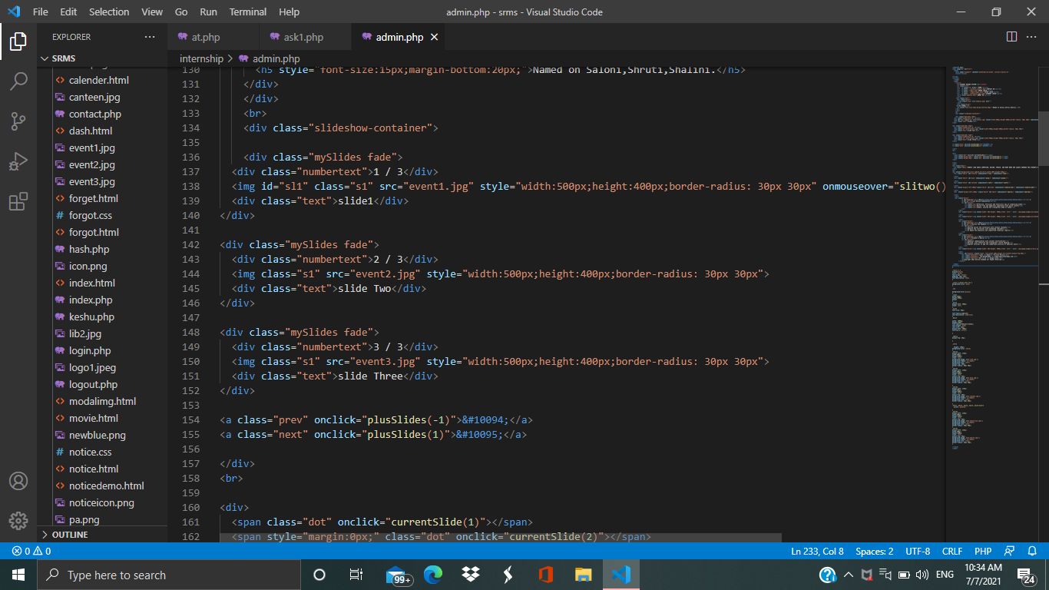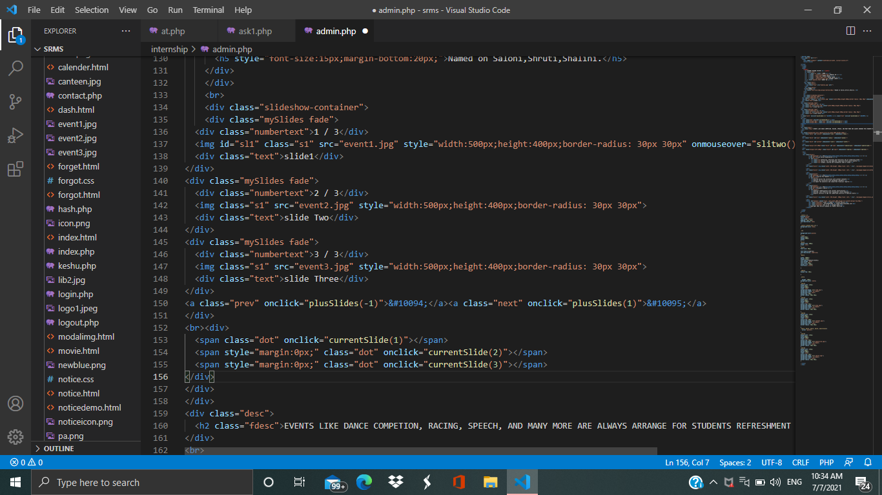**CODE**

**Home Page** 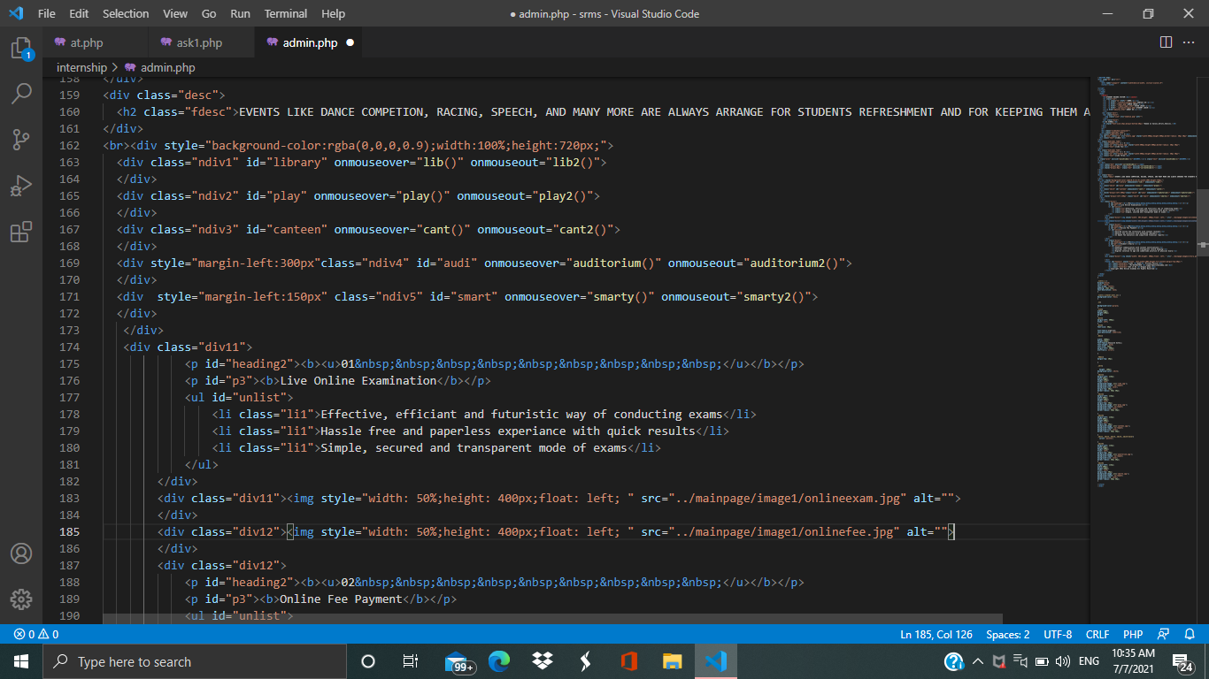 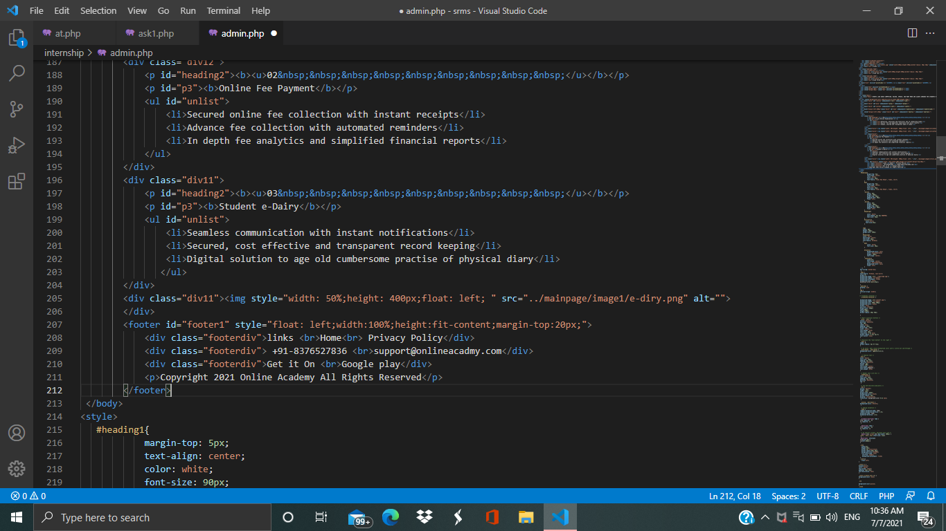

**Contact us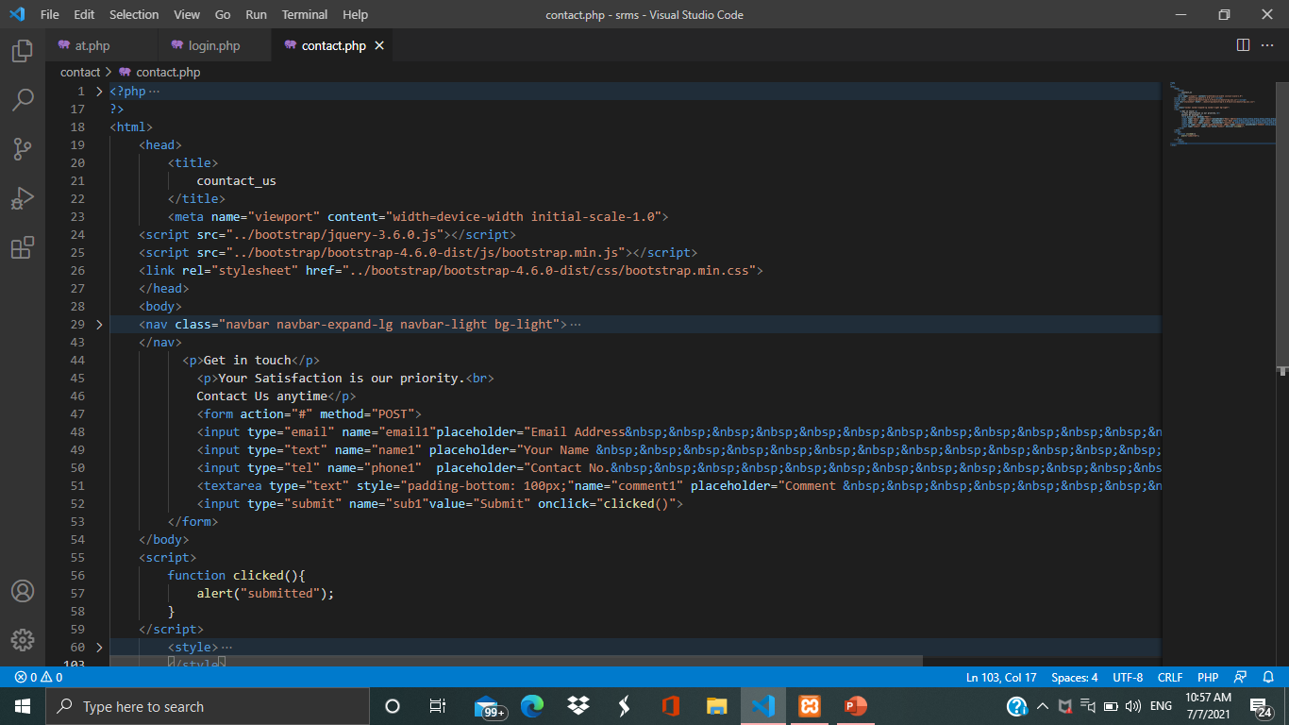 About Us**

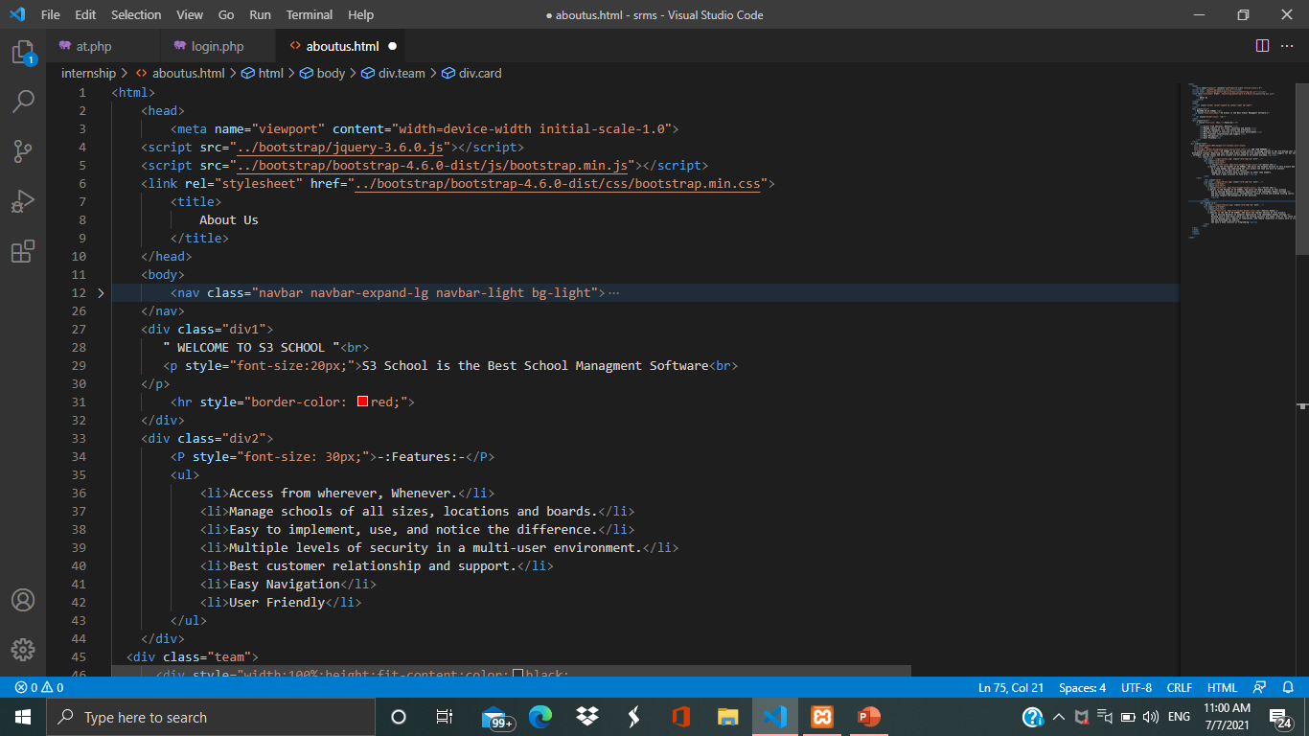

**Admin Sign Up**

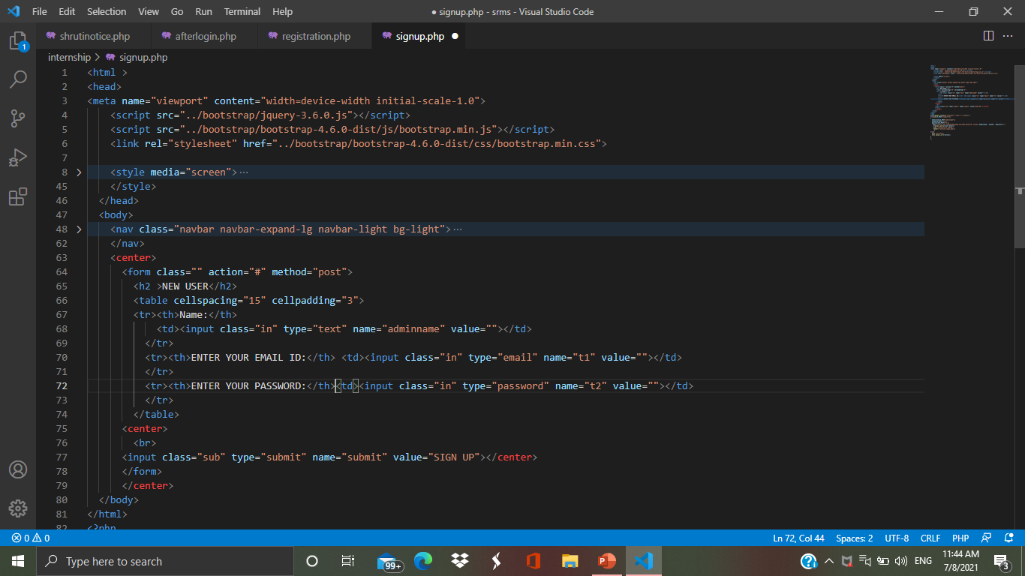       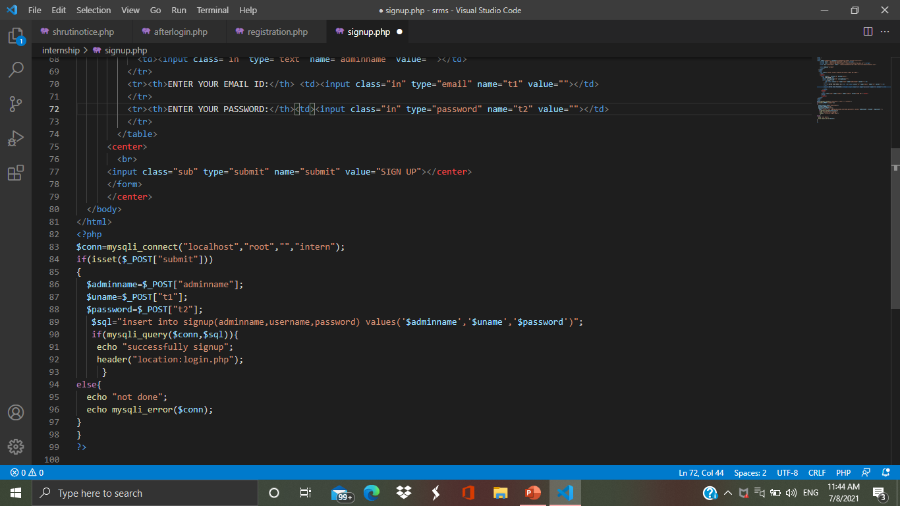

**Admin Login**

****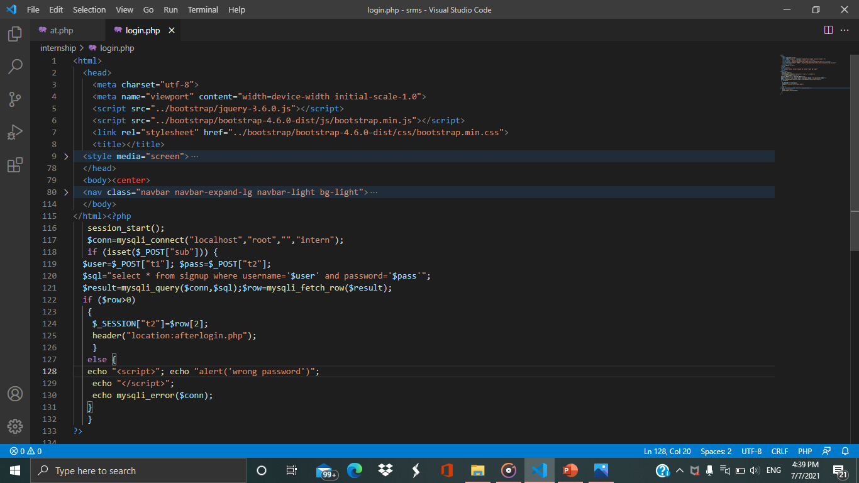

**Admin Home Page**

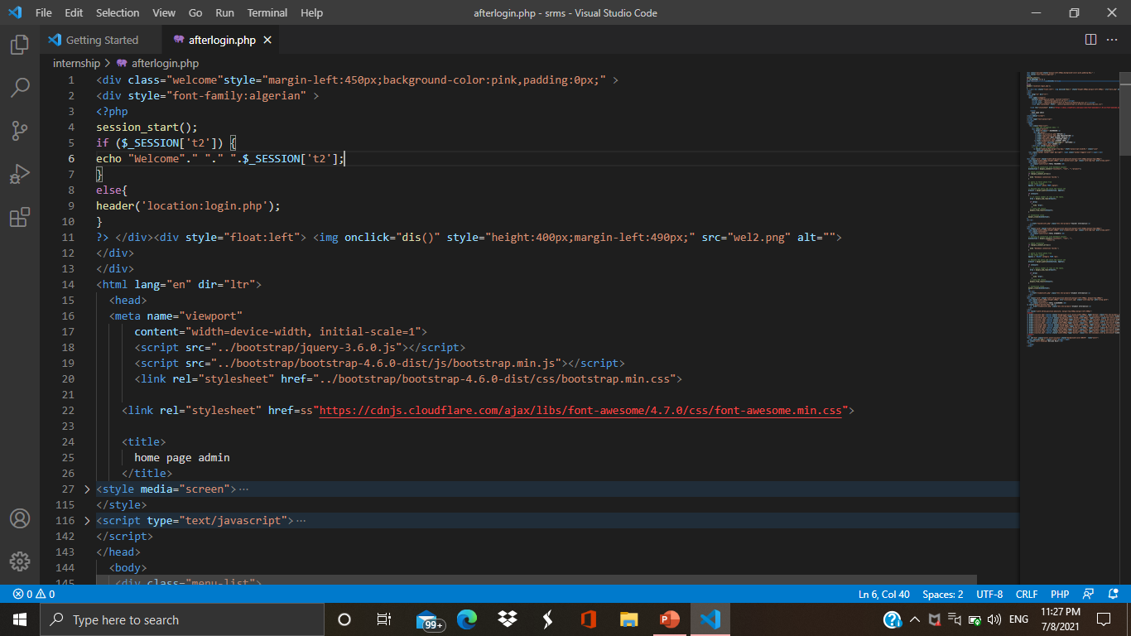       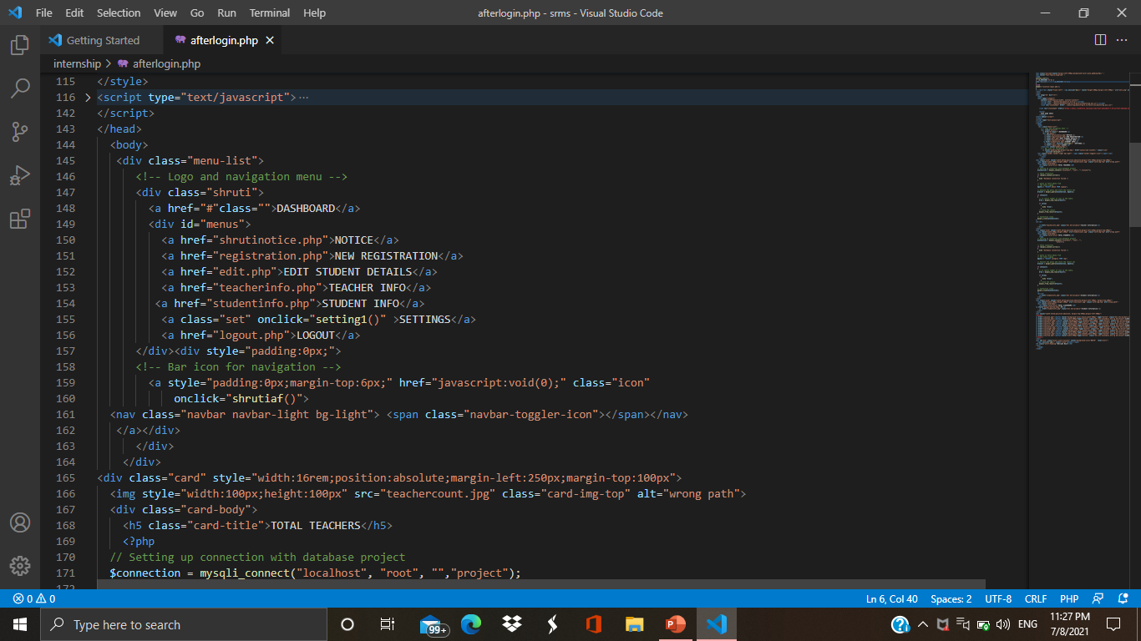

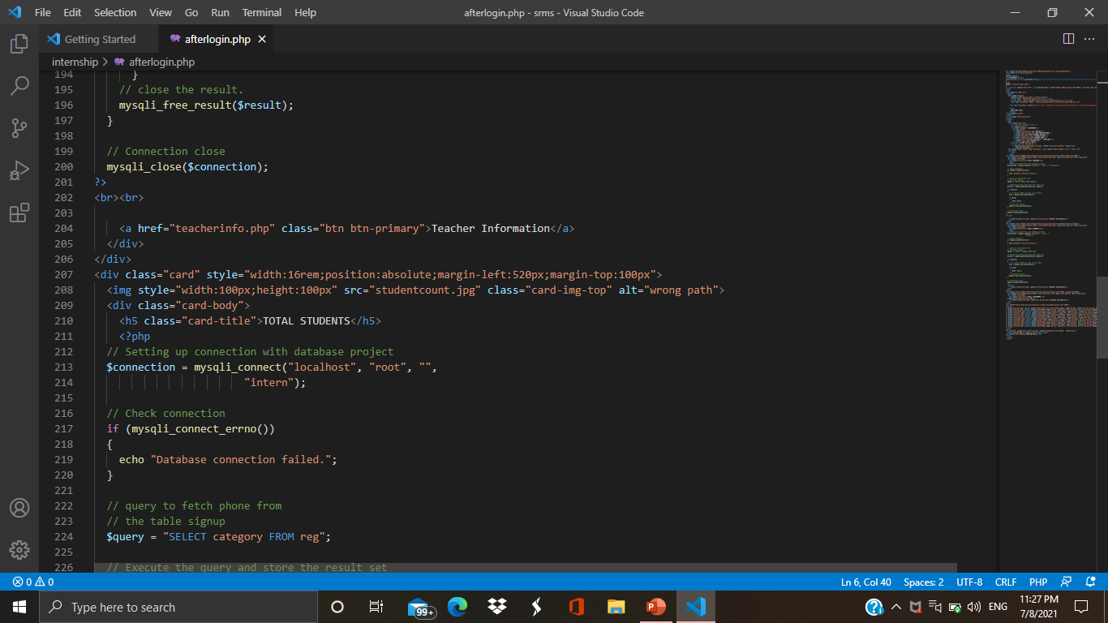 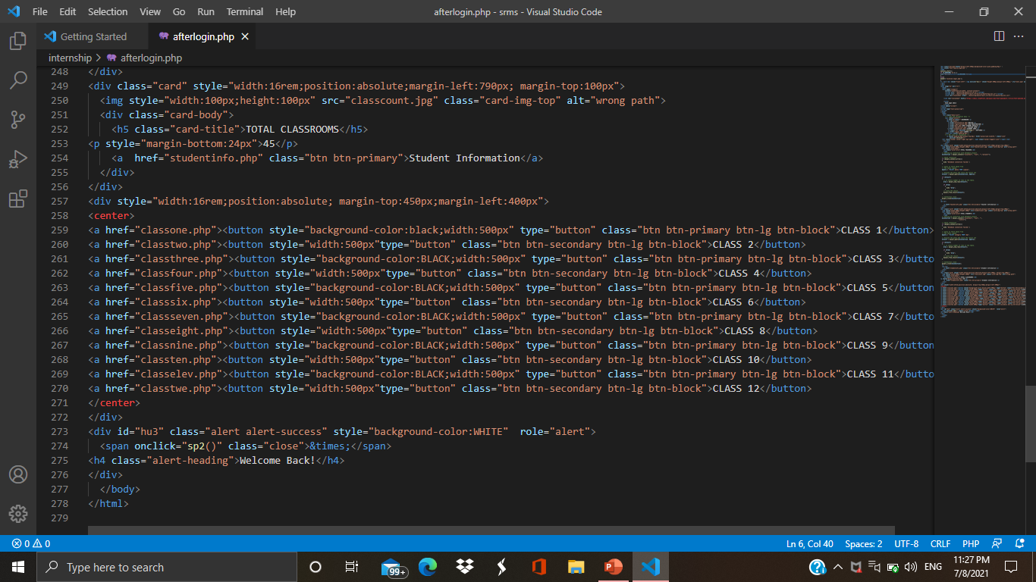

**Admin can see Teacher 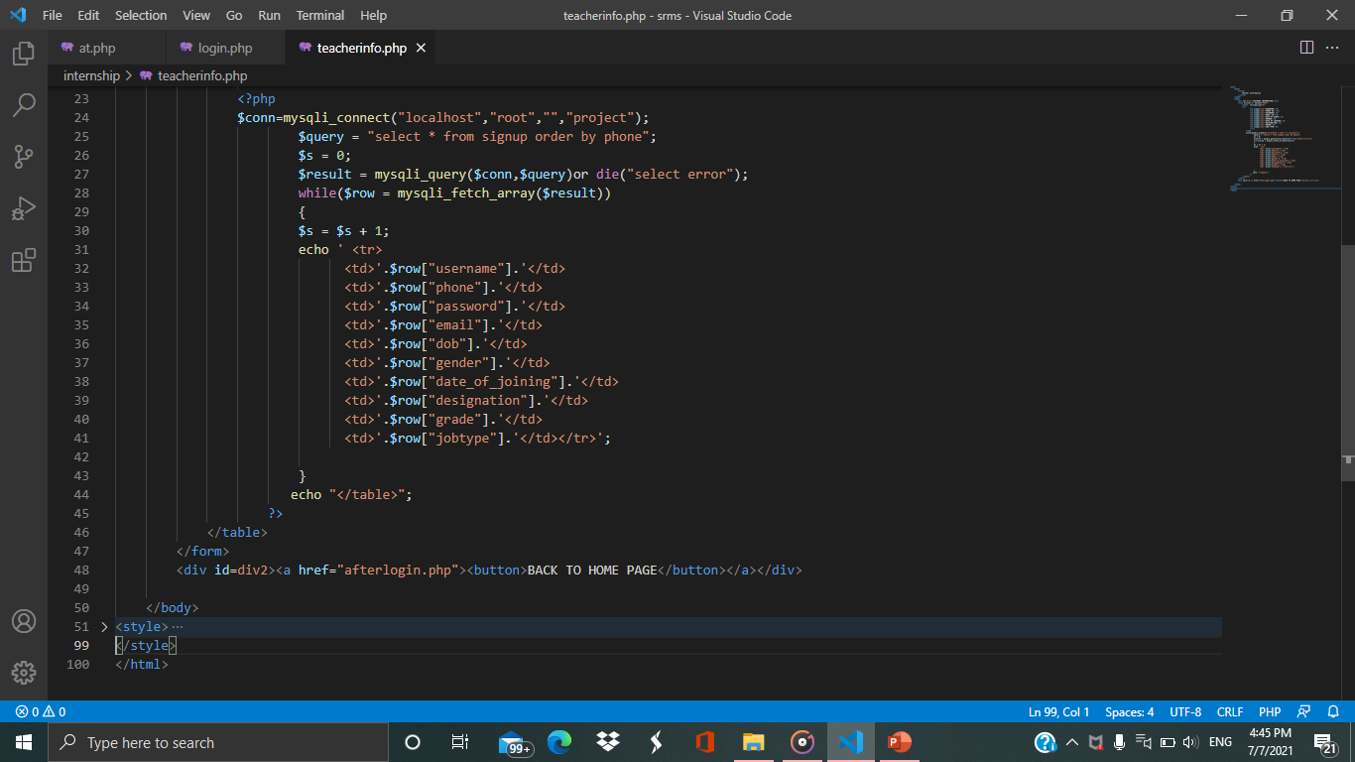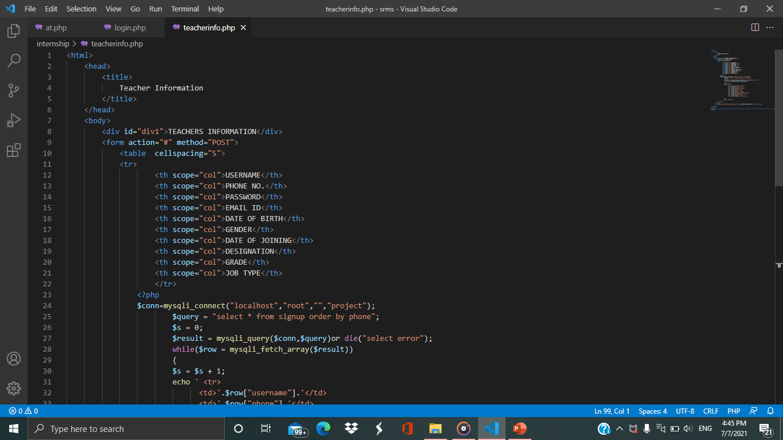Information**

**Admin can see Student Information**

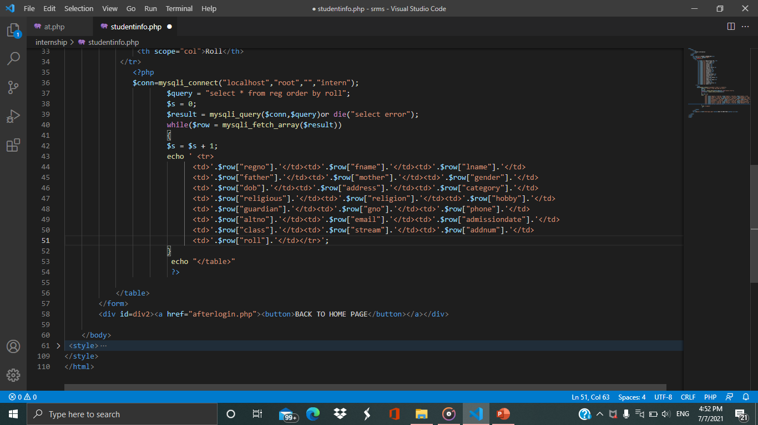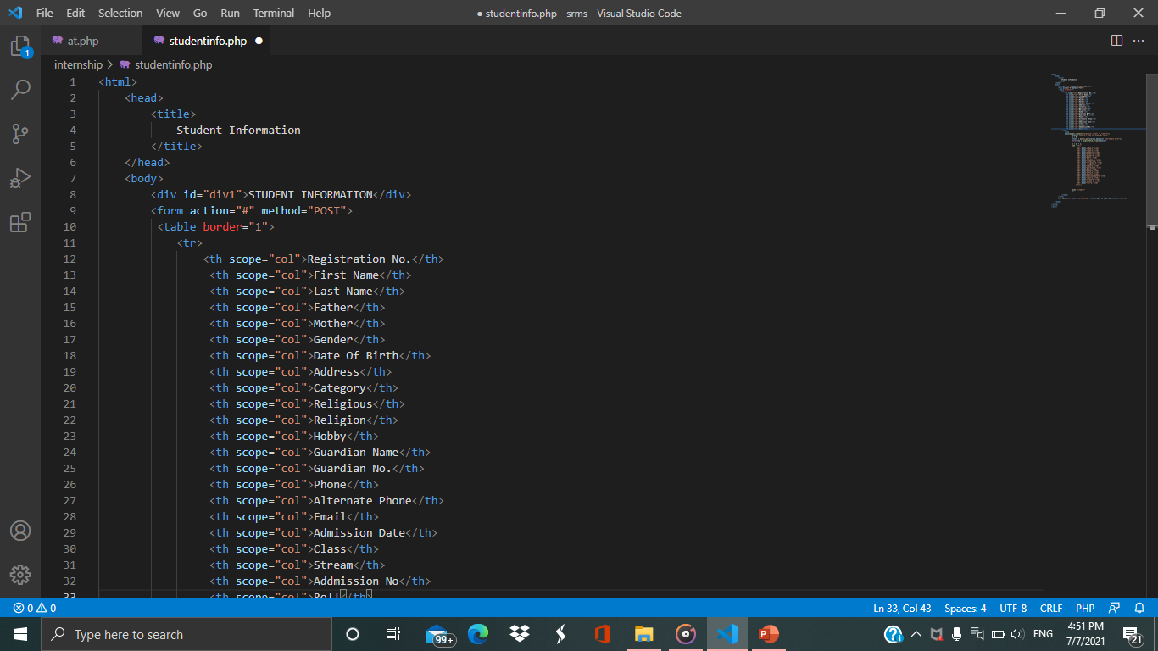

**ADMIN NOTICE**

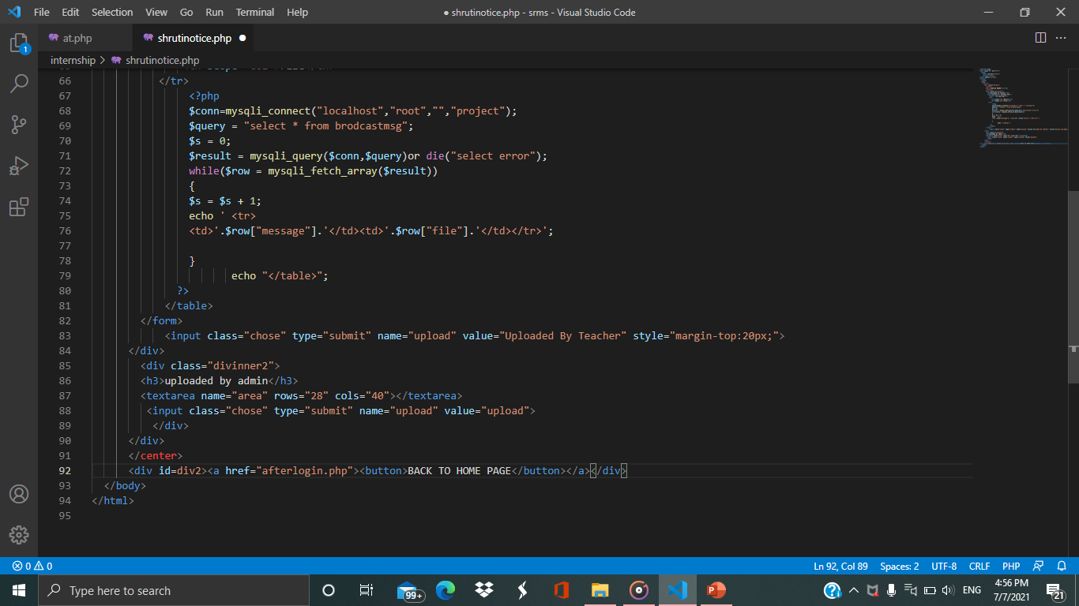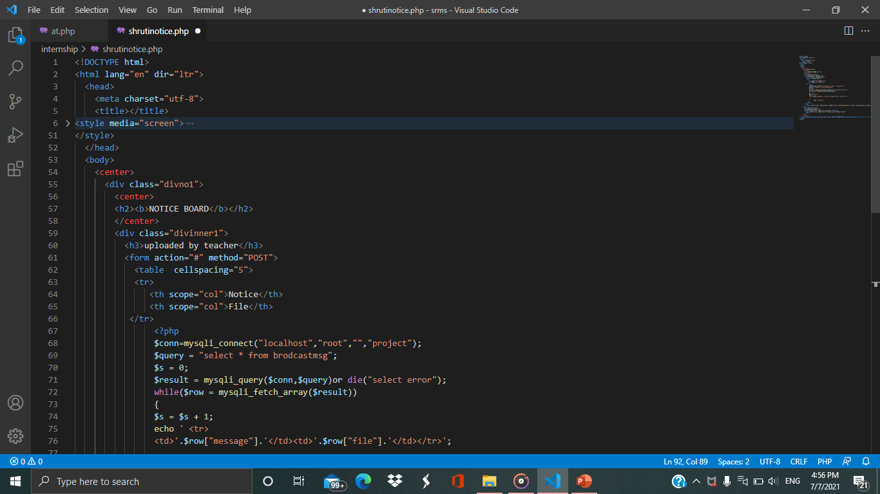

**New Registration**

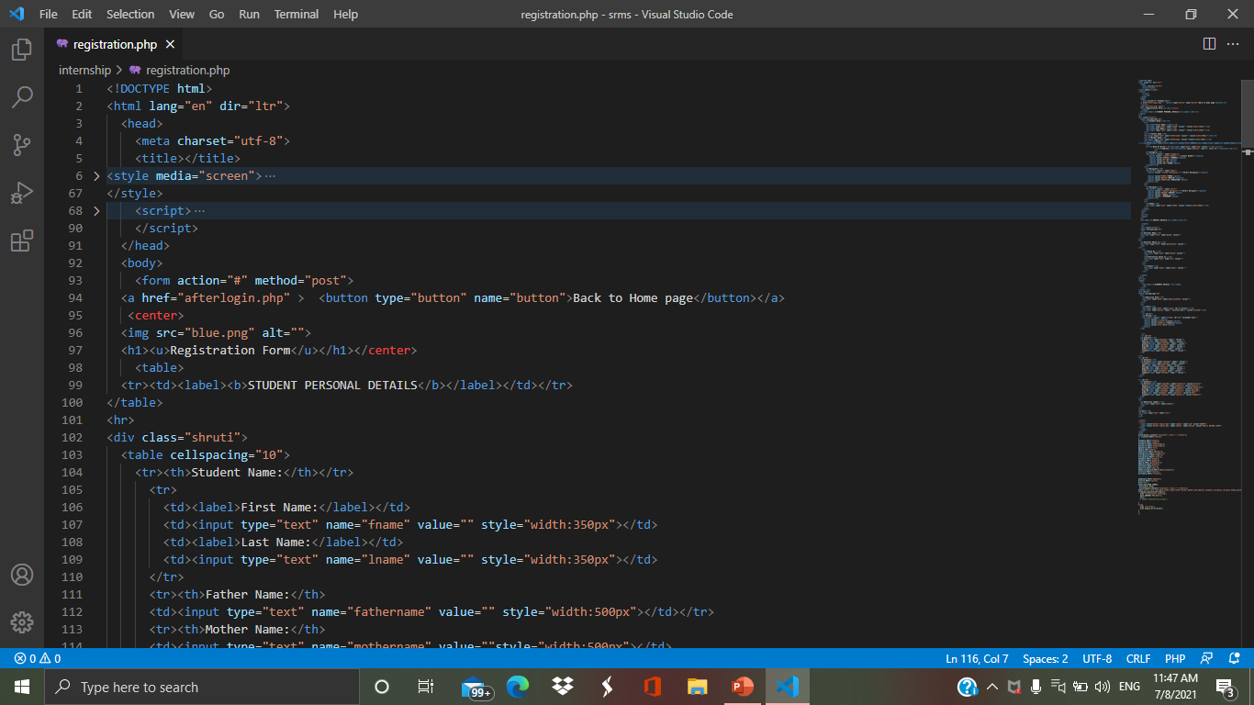 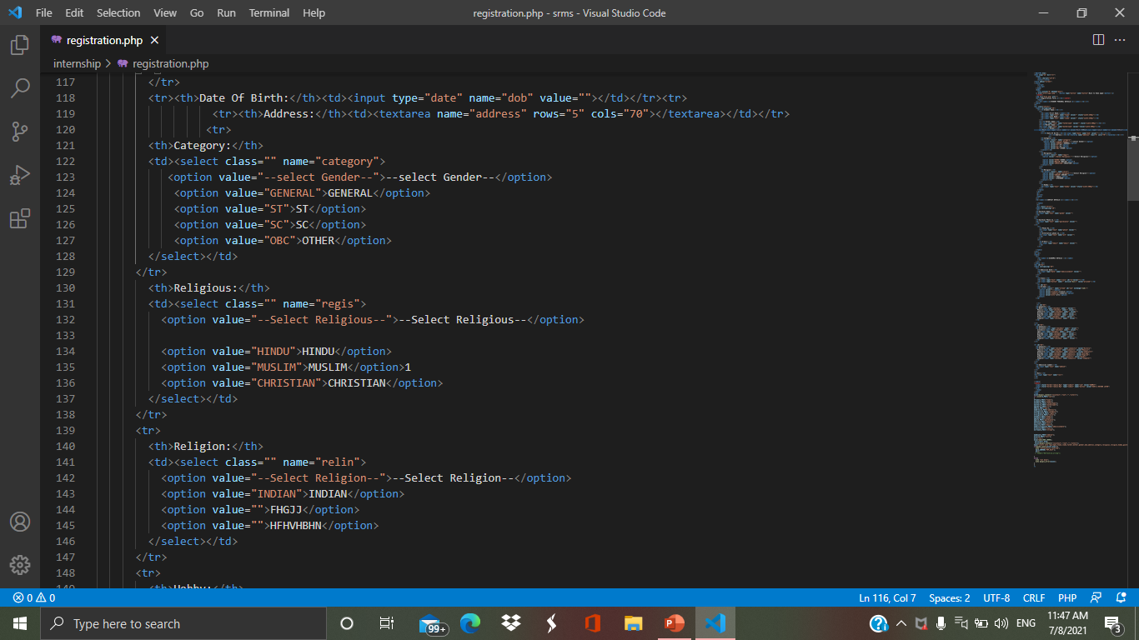

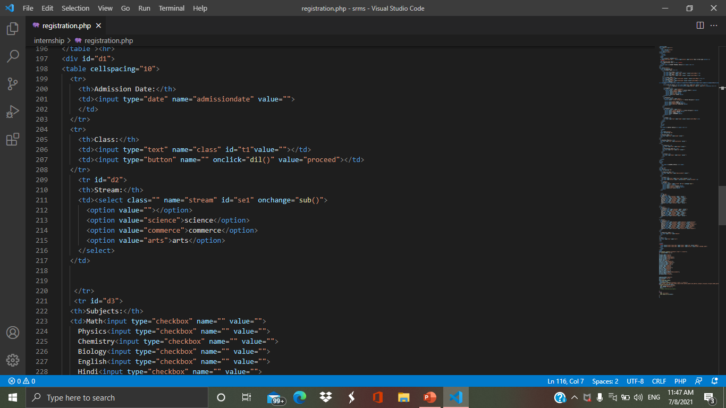 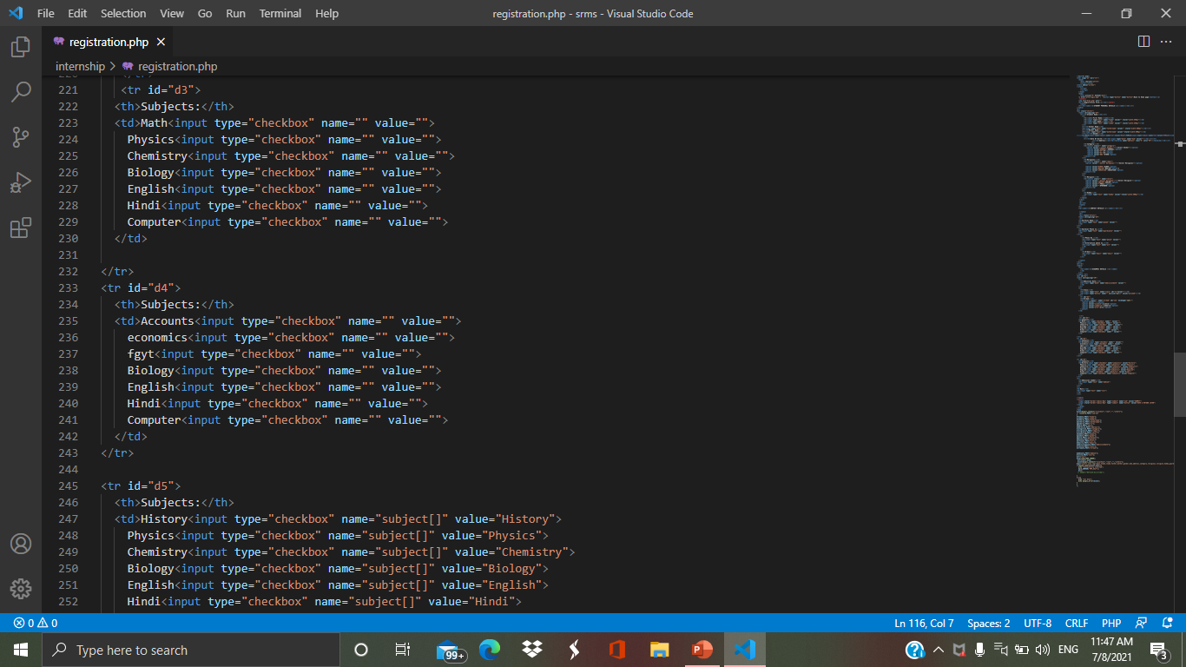

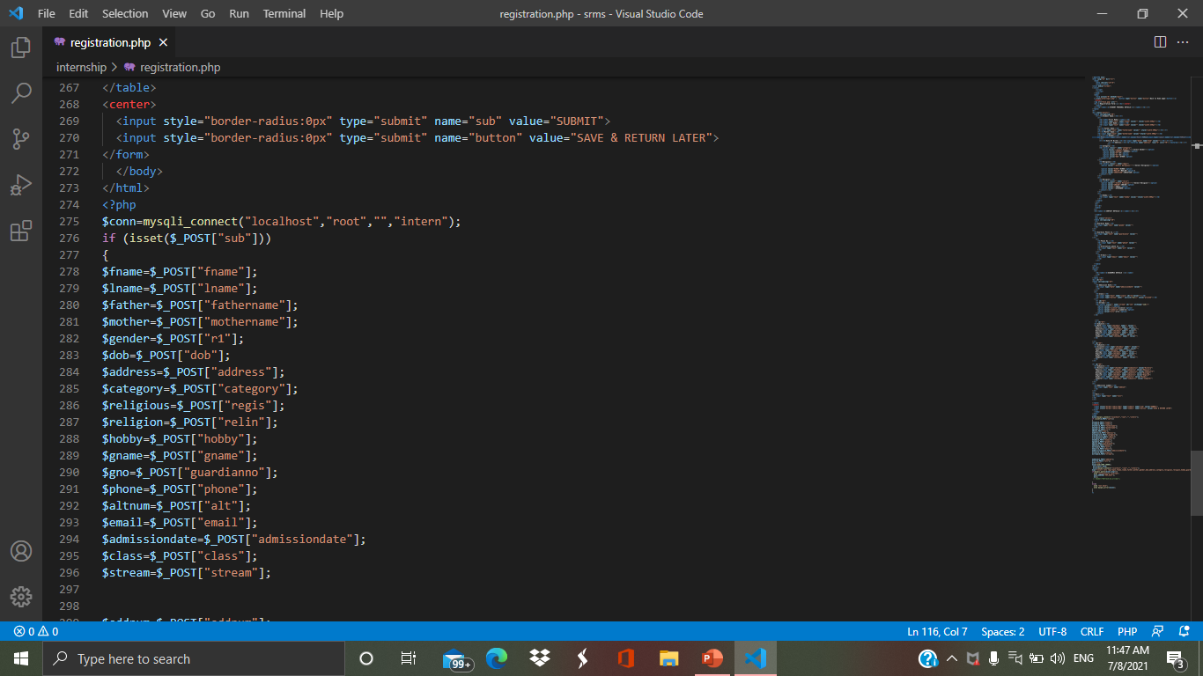 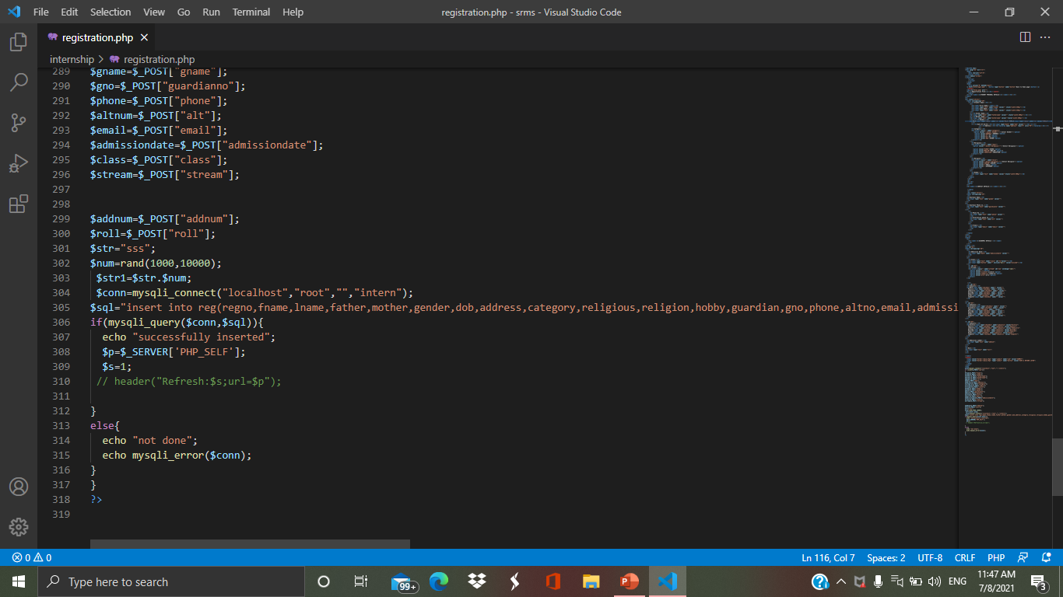

**Tutor Sign-up**

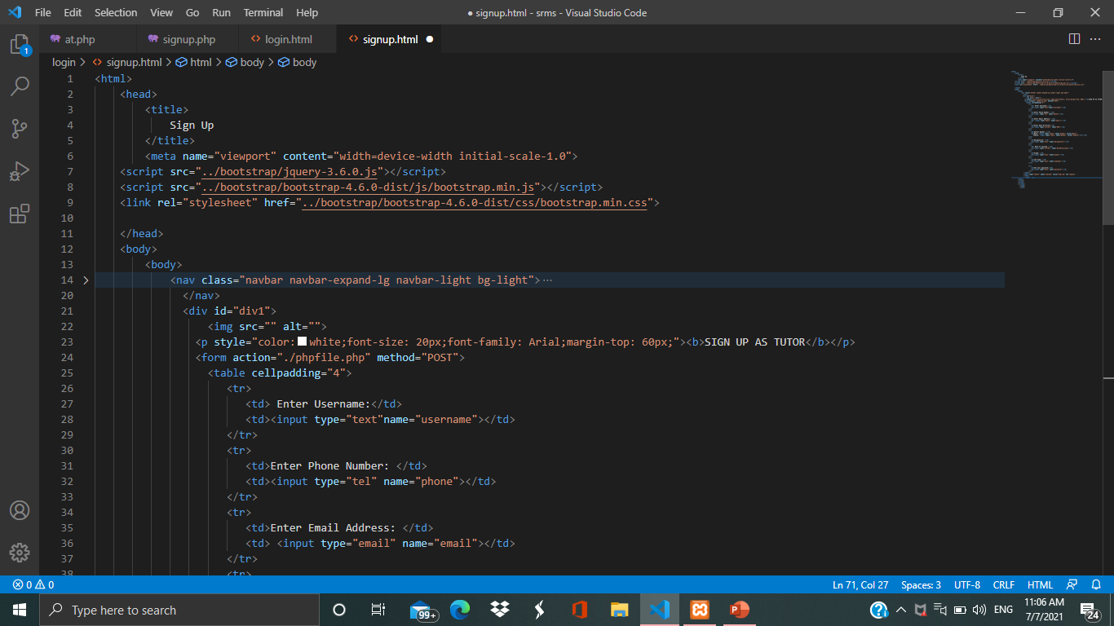

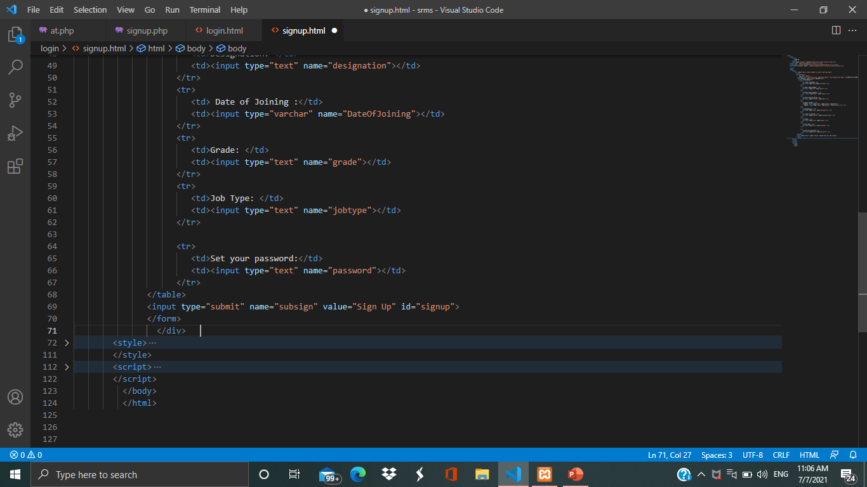

**Tutor Login**

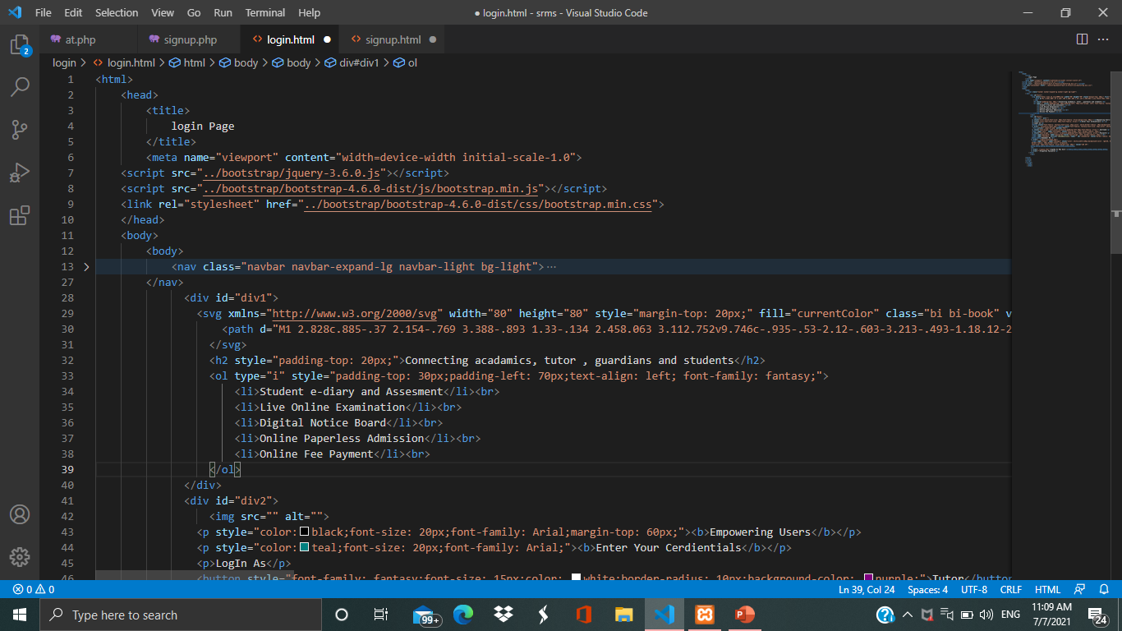

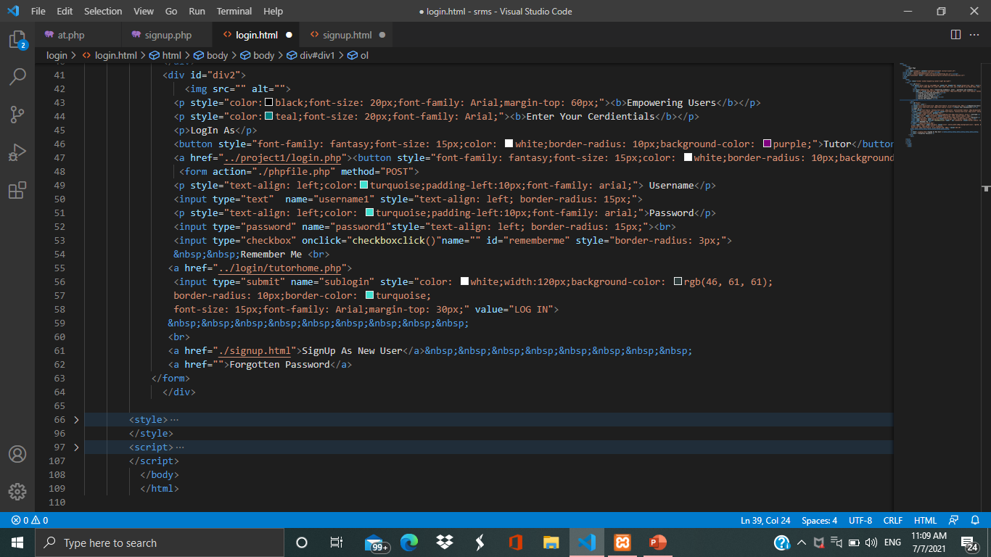

**Tutor Home Page**

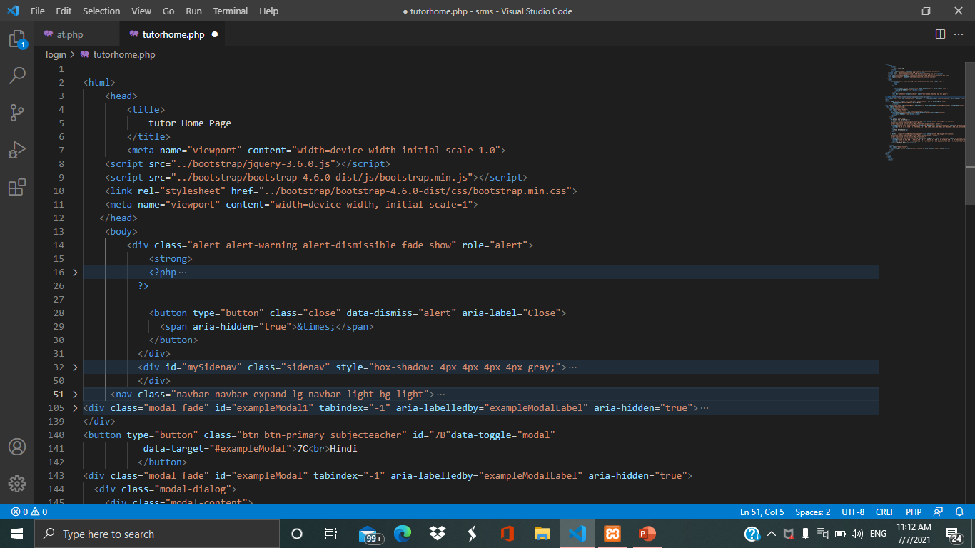

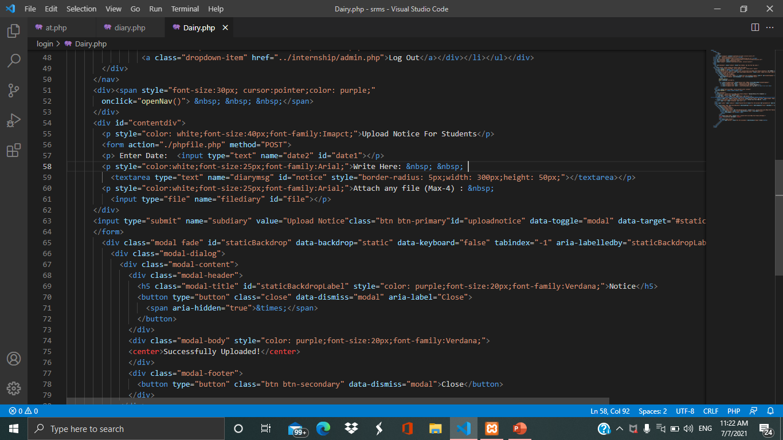

**Take Class Attendance**

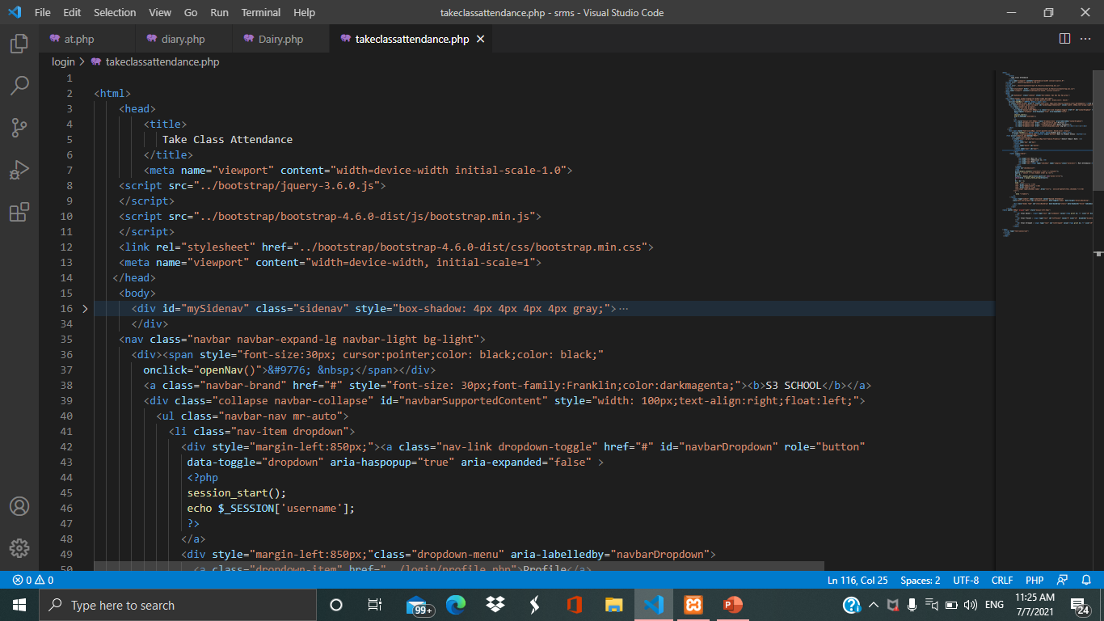

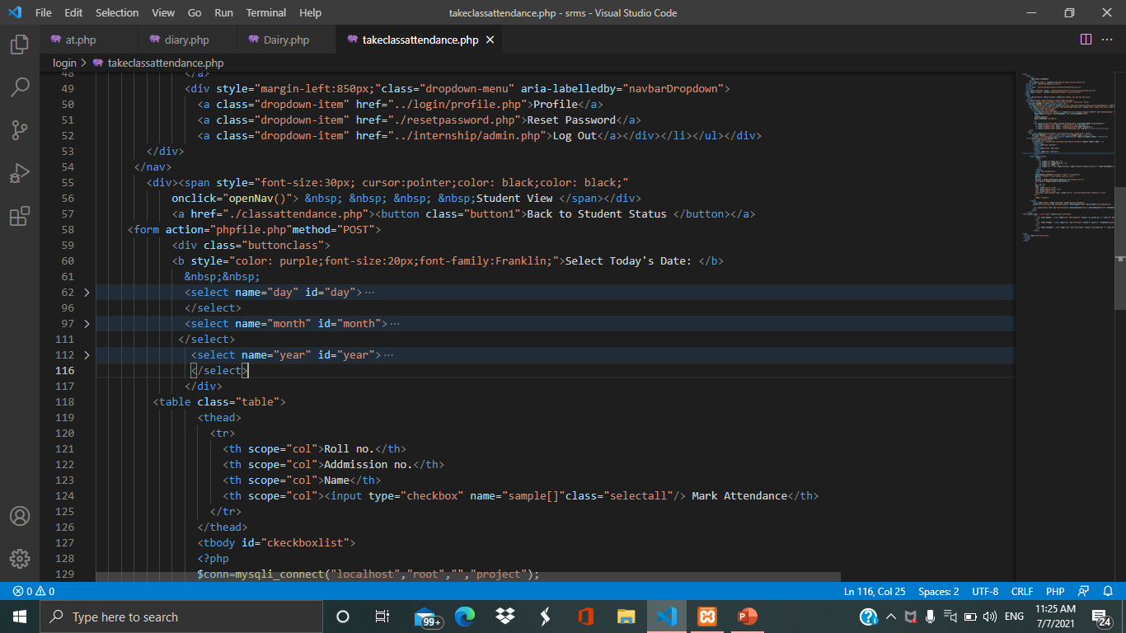

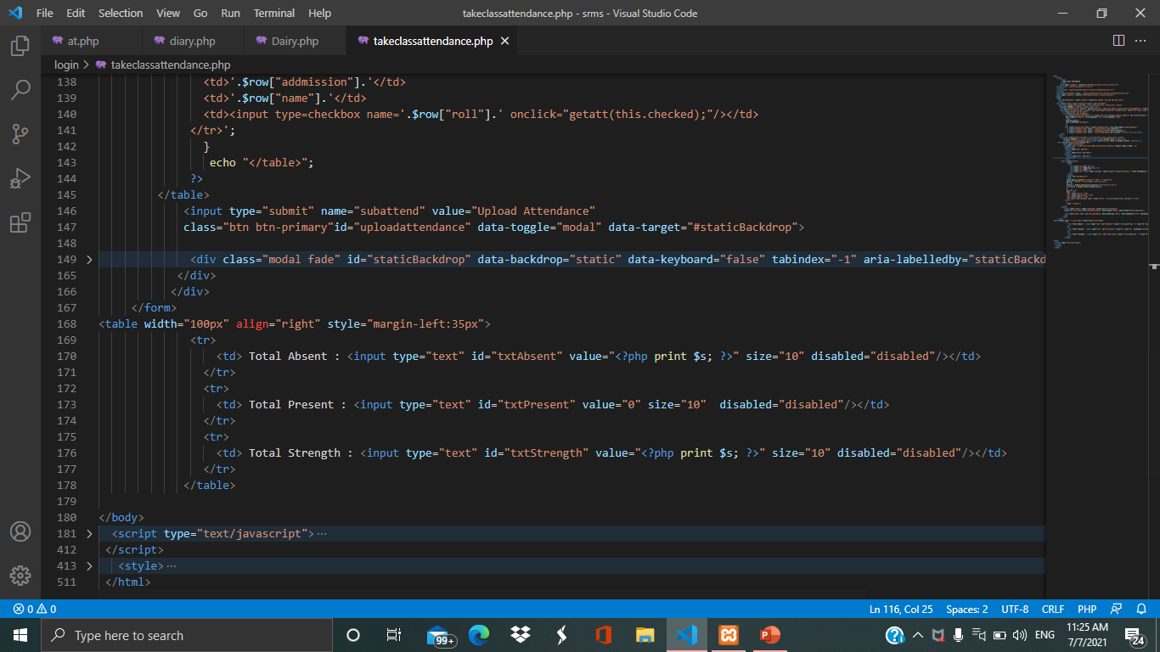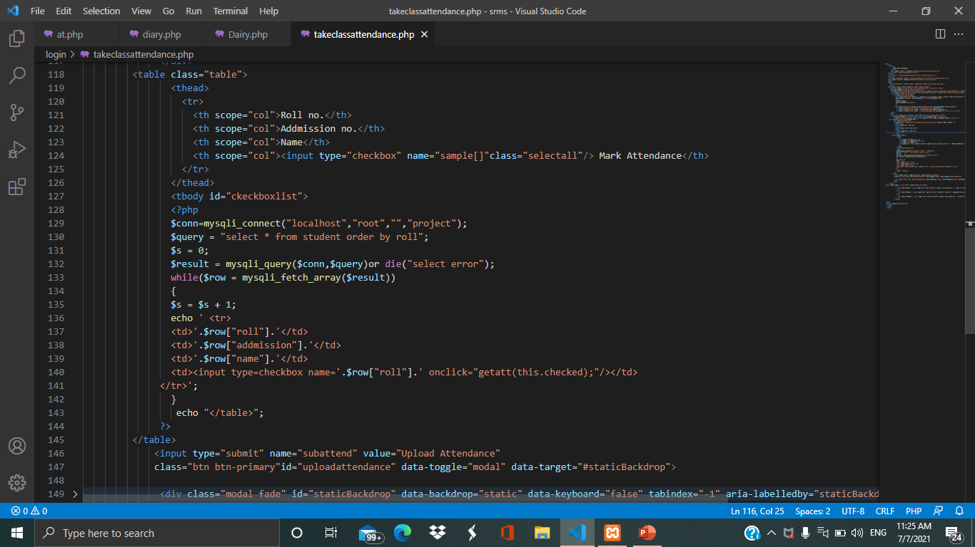

**Tutor Profile**

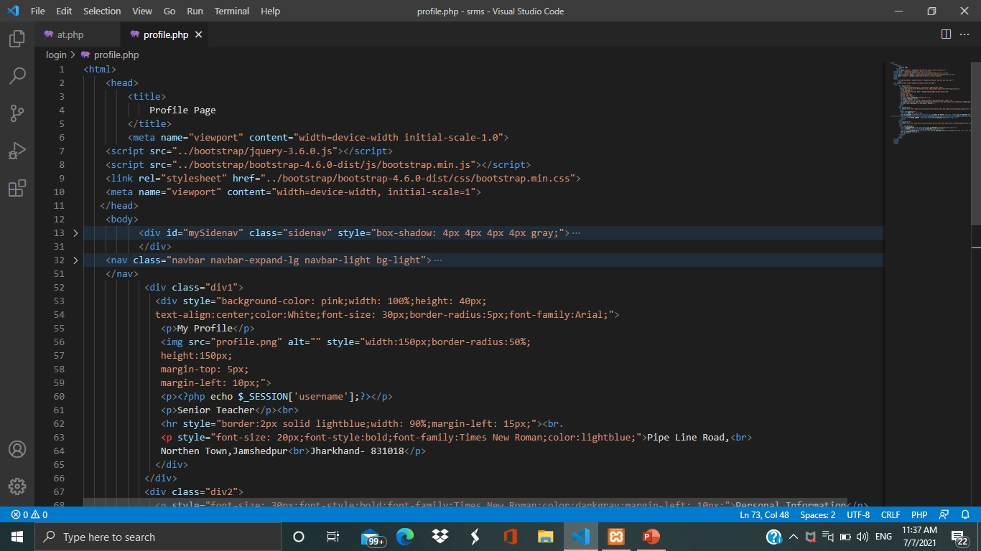 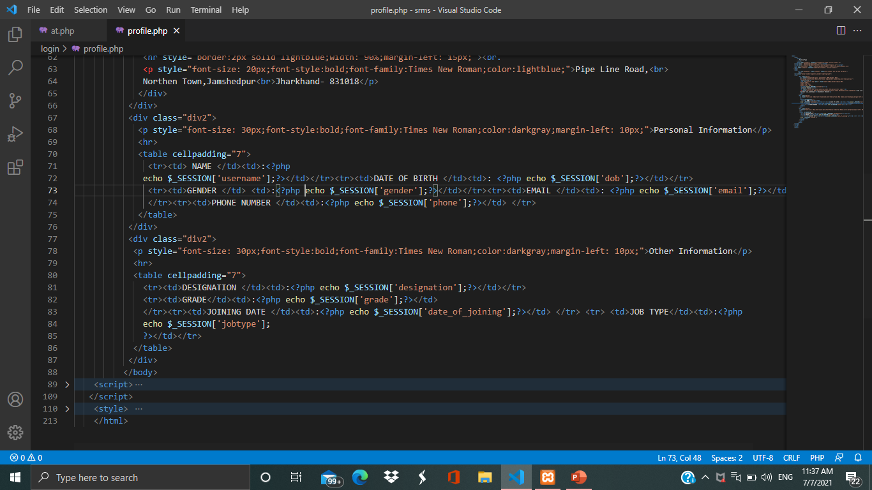

**Reset Password**

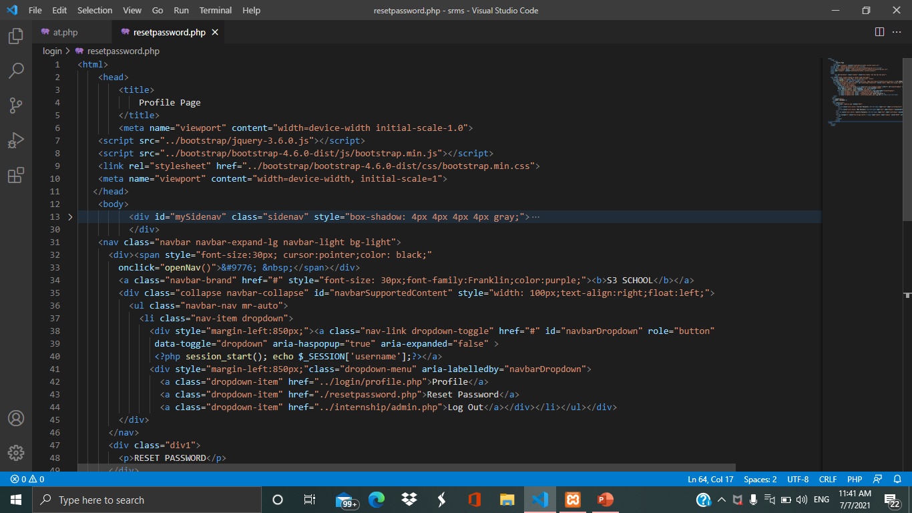 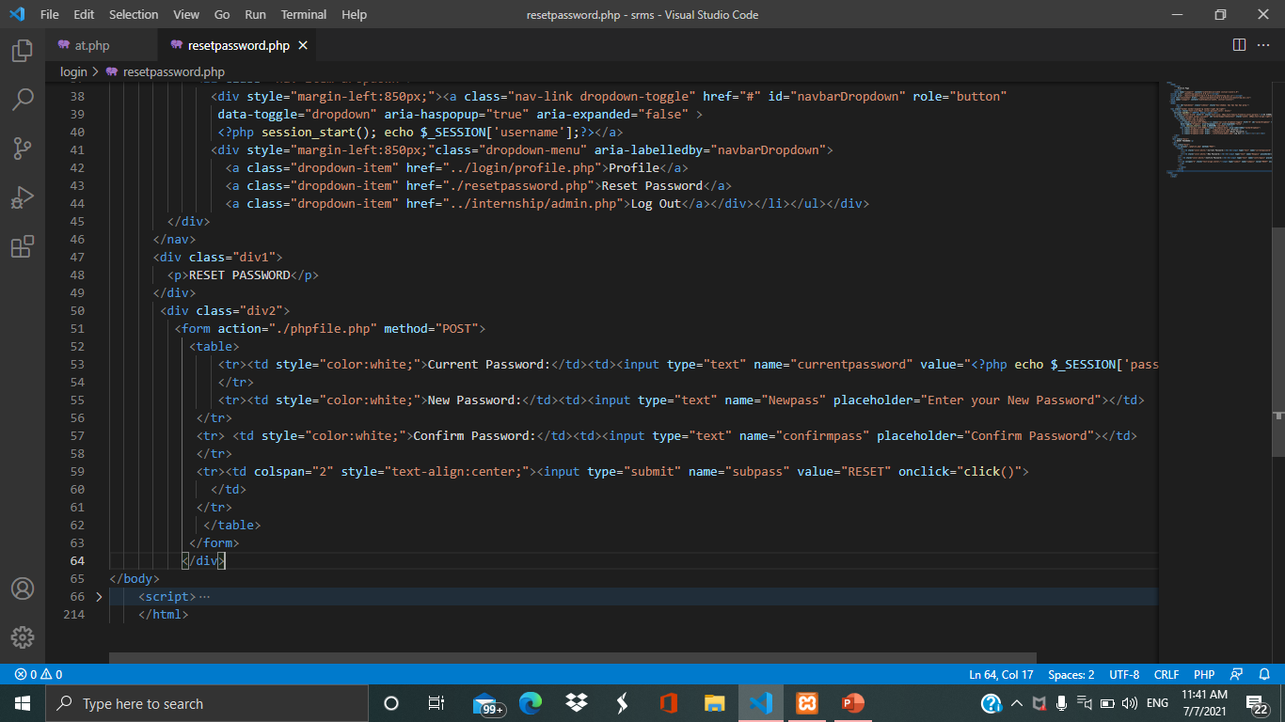

**Student Login**

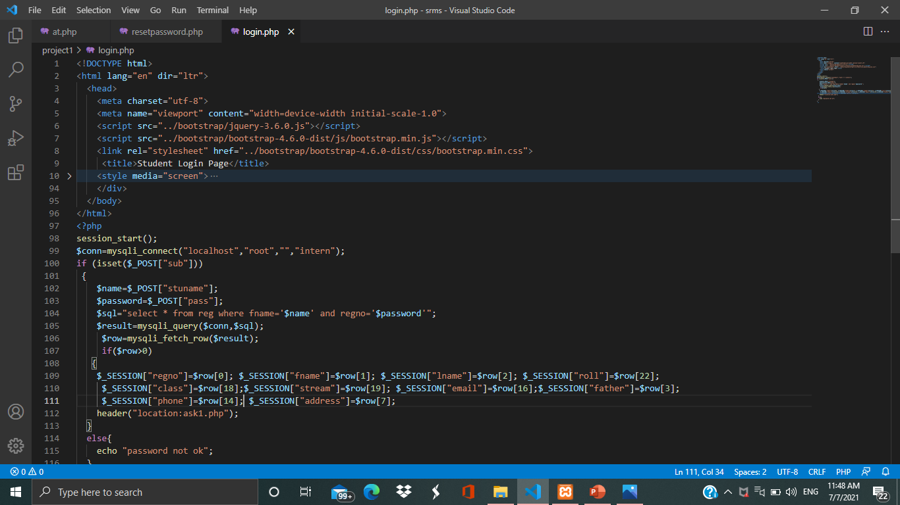

**Student Home Page**

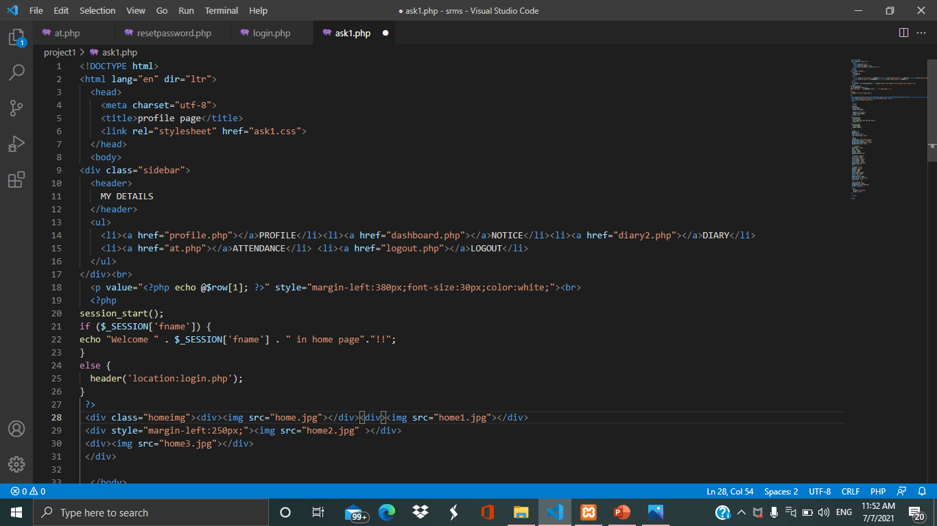

**Student Profile**

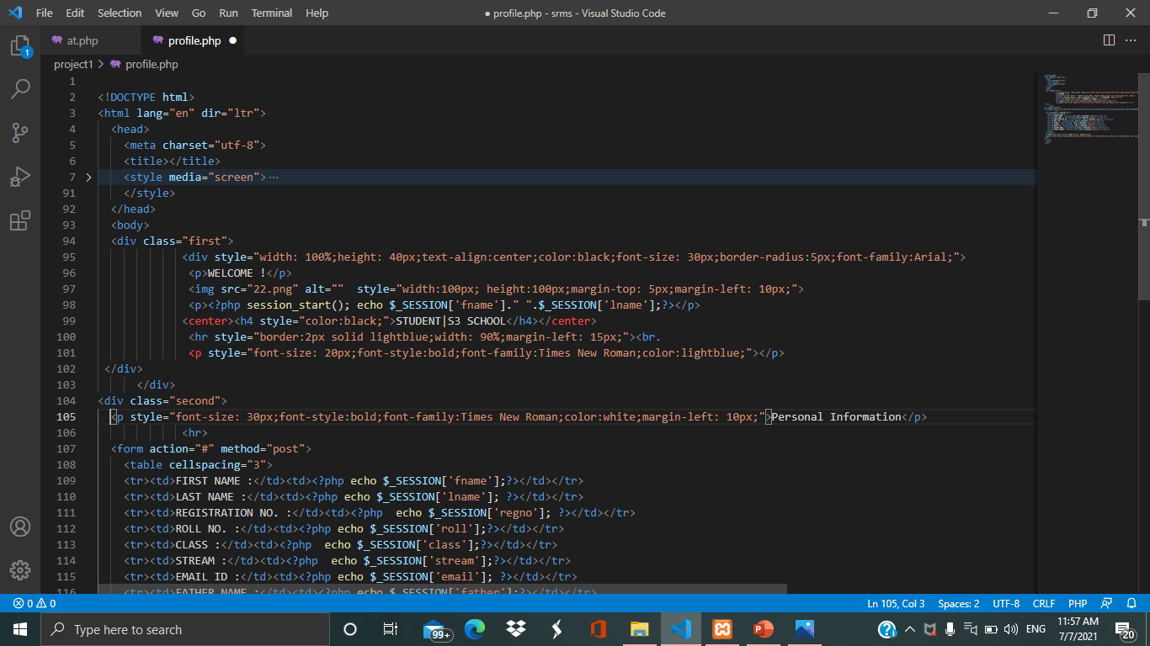

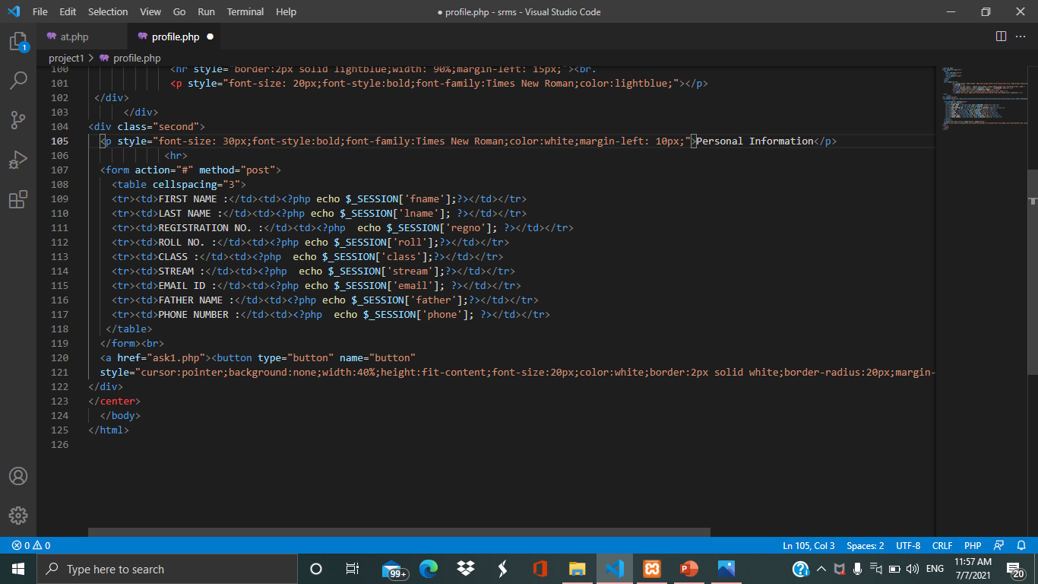

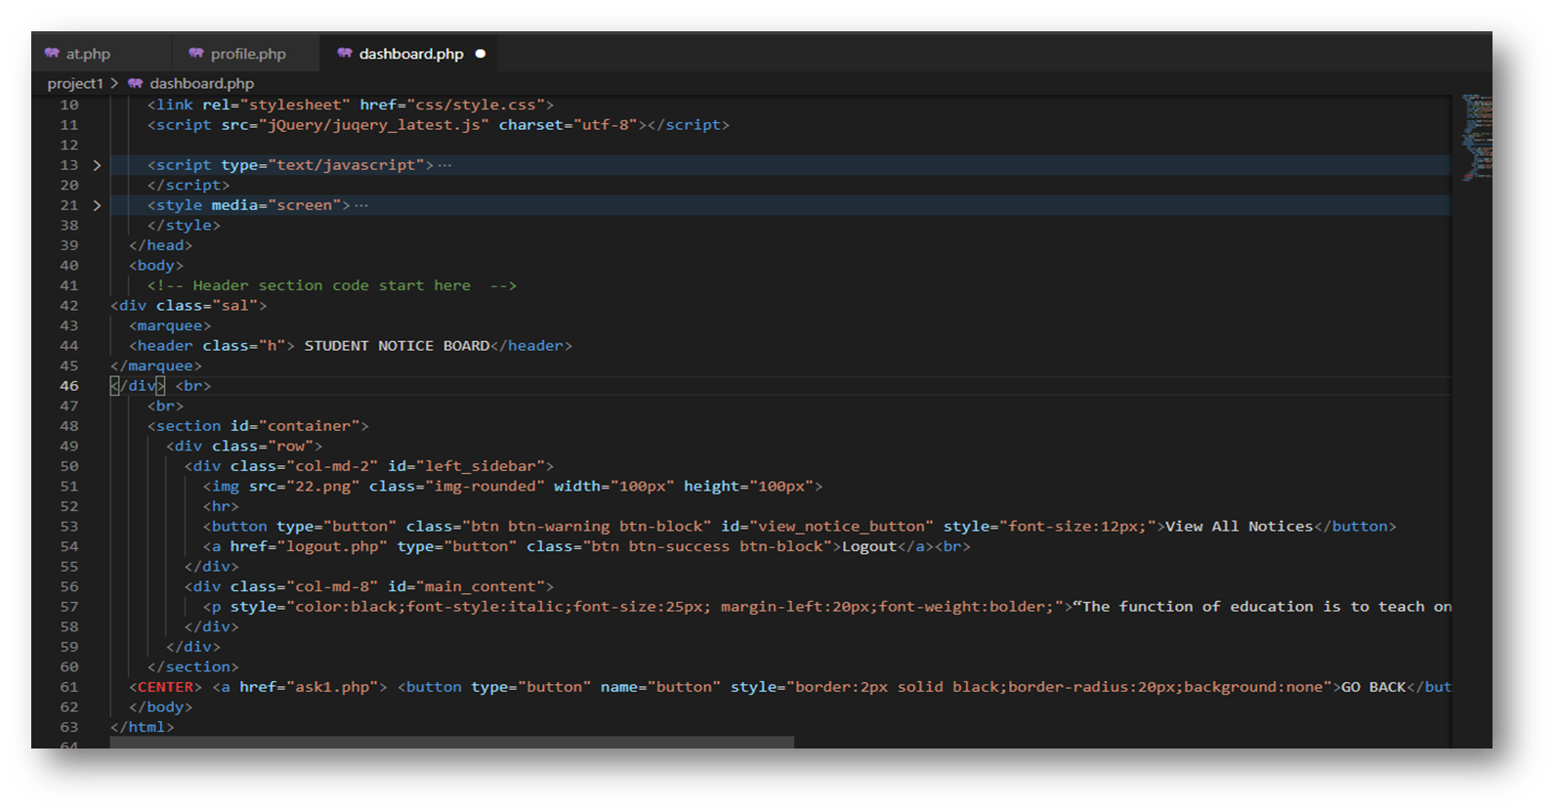**Student Notice**

**Student Diary**

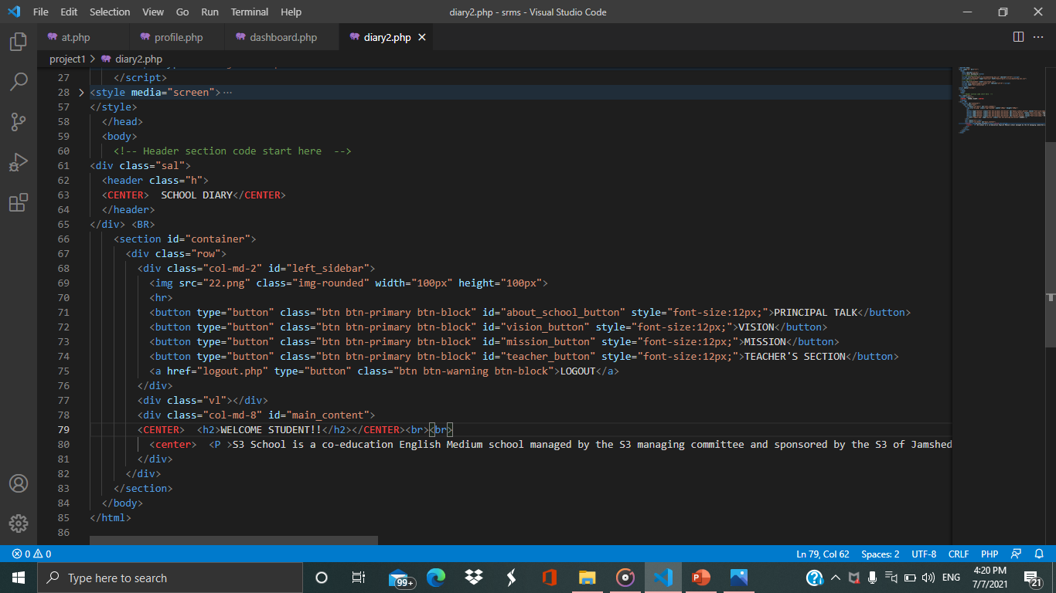

**STUDENT ANNUAL ATTENDANCE**

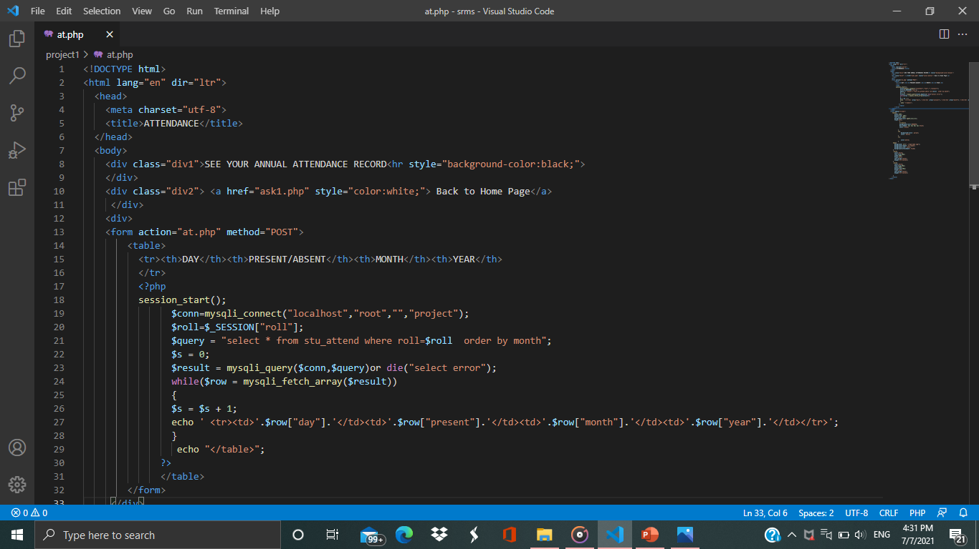

**CONCLUSION**

* This project has helped us in getting a clearer understanding of real-world Website development.
* • It has provided us a deeper in sight into connecting databases with servers.
* • The entire learning outcome of this project has proved to be immensely beneficial for our future application development.

**BIBLIOGRAPHY**

**We have taken help from :-**

* www.google.com
* www.geeksforgeeks.com
* www.youtube.com
* www.w3school.com
* Adityapur Auto Cluster IT Trainer Mr. Mannu Kumar.